*Landscape-scale urban pollinator occupancy rates are associated with natural habitat area and income.*

**Total word count:**

**8,900 not including references or fig/table captions**

Abstract = ~300

Introduction = ~1600

Methods = ~2,800

Results = ~700

Discussion = ~3,500

References =

Figure and table captions =

**Abstract**

As urbanization expands globally, there is a need to better understand the major drivers of urban biodiversity dynamics and the spatial and temporal scales at which these drivers operate. This need is critical for functionally important and widely declining insect pollinators. Although previous studies have determined that natural habitat and floral resources drive locally observed patterns of urban pollinator biodiversity, we lack an understanding of whether these drivers influence urban pollinator biodiversity patterns at the landscape-scale. To test the hypotheses that greater total area of undeveloped natural habitat and greater average income (with income used as a proxy for plant diversity and management resources) in an urban landscape promote pollinator biodiversity at the landscape scale, we applied an integrated Bayesian occupancy model to 12 years of natural history collections records, comparing occupancy rates of bumble bee and hoverfly pollinator species in 459 urban landscapes from across the United States that vary in the amount of natural habitat and income. We found that landscape-scale occupancy rates for the average bumble bee species is not significantly associated with the area of natural habitat in an urban landscape (1 standard deviation increase in landscape natural habitat area = [ , ] 95% BCI change in landscape occupancy rate), however, we found a positive association with average income (50% BCI = [,]). In contrast, we found a positive association between natural habitat area and hoverfly occupancy rate (95% BCI = [,]), emphasizing that natural habitat remnants such as greenbelts and nature reserves are critical for the maintenance of pollinator diversity in urban landscapes. Together, these results suggest that pollinator population dynamics are driven in part by the quality of the environment at spatial scales beyond those that are experienced by individual organisms. Given these results, local urban habitat restoration and enhancements must coordinate with city and regional planning policies to ensure the long-term success of species conservation.

1. ***Introduction***

Word count: 1616

The intensity and extent of urban land use is increasing globally (Simkin et al., 2022). By 2050, over 70% of the world’s population is projected to live in urban areas (United Nations, 2018). At the same time, urbanization is associated with changes to the composition and configuration of critical habitat and other resources, with the potential for negative impacts on biodiversity (McKinney, 2006; Grimm et al., 2008; Svenningsen et al., 2021). To reduce the loss of biodiversity and associated ecosystem services in an urbanizing world, we need to better understand the drivers of urban biodiversity patterns and the spatial and temporal scales at which they operate. Identifying these drivers is especially pressing for pollinators, a widely threatened functional group (Potts et al., 2010; Koh et al. 2016) that provides valuable ecosystem services across a variety of environments, including in urban systems (pollination of native plants that persist in cities and towns (Cheptou et al, 2006); and pollination in urban agricultural systems (Lin et al., 2015; Jha et al., 2023)).

Broadly, insect pollinator declines are driven by a combination of pressures including climate change (Oliver et al., 2017; Jackson et al., 2022; Janousek et al., 2023), species invasions (Valtonen et al. 2006; Moron et al., 2009; Aizen et al., 2019), pesticide use (Brittain et al., 2010; Rundlof et al., 2015; Janousek et al., 2023) and disease (Colla et al., 2006; Furst et al., 2014). Anthropogenic land use change may exacerbate insect pollinator declines through habitat loss and habitat fragmentation and, further, by amplifying other direct stressors (Winfree et al., 2009). For example, agricultural land simplification can drive greater pesticide use (Meehan et al., 2013). Similarly, insect pollinators in urban systems may face elevated industrial pollution (Sivakoff et al., 2020), higher diversity and abundance of introduced species (Fitch et al., 2019; Prendergast et al., 2021), increased pathogen pressures (Youngsteadt et al., 2015) and elevated temperatures due to the urban heat effect (Hamblin et al., 2018).

On the other hand, urban systems may provide opportunities for pollinator conservation (Baldock et al., 2020). The demographic rates, abundance and/or diversity of some pollinator taxa may increase along urbanization gradients (Baldock et al, 2015; Samuelson et al., 2019; Theodorou et al., 2020), although for some taxa and in other cities these general patterns do not always hold (Bates et al., 2011; Deguines et al., 2016; Theodorou et al., 2020). The variability of pollinator responses to urbanization calls for a better understanding of what makes an urban environment favourable for pollinator reproduction and survival and what types of species will benefit from different urban habitat management strategies (Baldock et al., 2020). To this end, a growing number of studies pinpoint drivers of locally observed urban pollinator biodiversity.

Undeveloped natural habitat remnants embedded in the urban landscape, such as urban greenbelts and nature reserves, may be critical for pollinators. Across many studies, locally observed pollinator abundance and diversity increases with the size of a natural habitat patch, suggesting that the presence and total area of undeveloped greenspace in an urban landscape impacts local pollinator demographics (Faeth & Kane 1978, Beninde et al., 2015). Urban bumble bee nesting densities are positively associated with the proportion of wooded habitat or forest cover in the surrounding landscape (Jha & Kremen 2013a; Conflitti et al., 2022), and losses of ground nesting wild bee species from pollinator communities are associated with high impervious surface cover (Ahrne et al., 2009; Banaszak-Cibicka & Żmihorski, 2012; Geslin et al., 2016), suggesting that pollinator nesting opportunities decline as natural habitat remnants are replaced. Given that local pollinator species and functional composition may differ in urban natural habitat remnants (or in closer proximity to these greenspaces) versus in the developed urban matrix, these habitat patches may provide unique nesting and food opportunities that are critical for some pollinator species – potentially sensitive species with more specialized resource or habitat use requirements (Matteson et al., 2013; Martins et al., 2017; Normandin et al., 2017; Turo et al., 2021; Prendergast et al., 2021).

Because they provide food in the form of nectar and pollen, flower resources are another key driver of local pollinator abundance and diversity (Kennedy et al., 2013; Hyjazie & Sargent, 2022). Availability of flower resources mediate the abundance and diversity of pollinators in the developed urban matrix (Simao et al., 2018; Adams et al., 2020; Cohen et al., 2021; Gerner & Sargent, 2022). At larger spatial scales, the abundance and diversity of flower resources can be difficult to directly assess, and so some studies have use proxy measures to quantify flower resources in the urban landscape including weighting land use types in the landscape based on expert opinion (Kennedy et al., 2013; Davis et al., 2017) or using remote sensing tools that capture coarse vegetation patterns (Leong & Roderick, 2015; Beduschi et al., 2018; Gonzalez et al., 2022; Casanelles‐Abella et al., 2022). Socioeconomic proxy measurements have also been used in urban biodiversity studies to represent availability of floral resources in the urban landscape (Leong et al., 2018). In both urban natural habitat remnants and in the developed urban matrix, income is a consistent predictor of plant diversity, particularly of woody-perennial plants, representing a ‘luxury effect’ (Hope et al., 2003; Martin et al., 2004; Birgimana et al., 2012; Clark et al., 2013; Kirkpatrick et al., 2013; Wang et al., 2015; Avolio et al., 2015; Nesbitt et al., 2019). Therefore, income has potential to be used as a proxy for the distribution of critical floral resources that pollinators depend on that exist within the developed urban landscape matrix (Leong et al., 2018). Studies directly quantifying the association between income and biodiversity of mobile organisms are more limited (Leong et al., 2018). For insects, local abundance and diversity has been both positively (Leong et al., 2016; Baldock et al., 2019) and negatively (Gledhill & James 2012; Lowenstein et al., 2014) associated with neighborhood affluence, although these conclusions have been made in part without disentangling potential effects of income from potential effects of the intensity of urban development.

From these studies there is a growing understanding of how the urban environment shapes patterns of pollinator biodiversity that emerge at the short-term, local scale, that is, of how pollinator biodiversity patterns responds to the urban environment experienced by individual organisms. Yet, we lack an understanding of whether differences among the particular compositions of urban landscapes, such as the total area of natural habitat harboured by a city or the distribution of floral resources across a city, predict patterns of biodiversity (Aronson et al., 2016; Magle et al., 2019). Because dispersal among populations in a shared landscape can compensate for local population extinctions that might occur due to demographic or environmental stochasticity, ecological theory predicts that the persistence of a species as a whole in a landscape should be driven not only by the quality of local habitat experienced by individual organisms but also by the environment collectively experienced by interconnected populations (Hanski, 1999; Leibold et al., 2004). That is, that a species should be more likely to persist in a landscape as the total area of favourable habitat in the landscape increases (Hanski, 1999; Leibold et al., 2004). If the landscape-scale urban environment mediates the landscape-scale persistence of a species, then isolated local habitat amendments may be insufficient to support city-wide biodiversity in the long run and city-wide efforts would be needed to ensure that habitat patches are maintained across the landscape (Magle et al., 2019; Chase et al., 2020). Furthermore, changes in pollinator biodiversity that emerge on the short time scales considered by most studies (typically 1 – 3 years) may be driven by movement and redistribution of mobile individuals as opposed to demographic responses to the environment that increase the total number of pollinators in the urban landscape (Veddeler et al., 2006; Tscharntke et al., 2012; Magle et al., 2019). By comparing landscape-scale, multi-year biodiversity metrics among urban landscapes, we can identify whether city-wide management, design and policy strategies are needed to realize long-term urban biodiversity conservation goals.

Because they span broad spatial and temporal scales, proliferating natural history collections data (“NHC’s”) – including both community science data and digitized research collection records – present novel opportunities to examine drivers of long-term, landscape-scale biodiversity patterns (Kery et al., 2010; Guzman et al., 2021; Jackson et al., 2022; Shirey et al., 2022; Davis et al., 2022; Janousek et al., 2023). With a focus on bumble bees and hoverflies as indicators of urban pollinator biodiversity, we utilize NHC’s to test two hypotheses that link differences among urban landscapes to landscape-scale species occupancy. We use species occupancy as a summary metric of species-specific demographic trends, where a higher proportion of species occupying an urban landscape also implies higher species richness (He & Gaston, 2000; MacKenzie & Nichols, 2004; Kery & Royle, 2020). First, we test the hypothesis that undeveloped natural habitats embedded in the urban landscape predict local pollinator species occupancy and, simultaneously, that greater overall area of natural habitat in the urban landscape compensates for local extinctions thereby driving higher pollinator occupancy rates at the landscape-scale. Second, using income as a proxy for plant diversity and management resources, we test the hypothesis that higher income favours pollinator occupancy by driving more abundant and diverse foraging opportunities within the urban matrix and, simultaneously, that higher average income of an entire urban landscape promotes landscape-scale pollinator occupancy by increasing the spatial distribution of these favourable foraging opportunities. We therefore predict that pollinator occupancy patterns in urban landscapes will be positively associated with total natural habitat area and average income of an urban landscape. Further, by testing for a negative correlation between species-specific effect of natural habitat area on occupancy and species-specific range wide occupancy rate (including in non-urban landscapes), we assess the hypothesis that occupancy of rare versus common species is more dependent on the total natural habitat area in the urban landscape.

1. ***Methods***

Word count: 2,800

Occupancy models are typically applied to presence/absence data (MacKenzie et al., 2002; Kery & Royle, 2020). However, recent studies show that in combination with appropriate data-level and model-level structural decisions they can be applied to presence-only NHC’s including digitized museum records from research collections as well as community science observations (Kery et al., 2010; Guzman et al., 2021; Jackson et al., 2022; Shirey et al., 2022). Here, we summarize data preparation and our implementation of an integrated, multi-species occupancy model for urban pollinators, with full details provided in the Supplemental Methods accompaniment.

To generate our results, we used RStan (Stan development team, 2023a) to implement Bayesian statistical models written in the probabilistic programming language Stan (v2.31.0, Stan development team, 2023b). Data preparation and production of summary statistics was conducted using R (version ). Code to simulate urban pollinator communities, prepare the data, and/or reproduce the results are available at https://github.com/jensculrich/occupancy_model_for_urban_NHC_records.

***2.1 Data Collection***

***2.1.1 Site-level Data***

To define a set of urban landscapes we first overlayed the continental United States with a 10 km $×$ 10 km grid (as in Janousek et al., 2023), extracted the average population density from each grid cell (CIESIN, 2018) (supplemental figure 1), and then filtered out grid cells that did not meet a minimum population density threshold of 1200 people/km².

Because species occurrence rates are expected to increase with study area (Preston 1960), we calculated and controlled for the total land area of each site, subtracting open water (Dewitz & USGS, 2021) or area outside of the continental U.S. (Walker, 2022). Because we consider that detection data originating from finitely small sites may be a product of fewer community science contributors and consequently more subject to inconsistent individual contributor behaviours, we filtered out any urban landscapes that were comprised of less than 25% land area (supplemental figure 2), resulting in the final set of urban landscape sites used for each analysis (n = 459 sites) (Figure 1).

We extracted environmental covariates from each urban landscape using national land cover and socioeconomic data. We used 30 m $×$ 30 m resolution land cover data from 2016 to determine the amount of natural habitat in each urban landscape (Dewitz & USGS, 2021), calculating the summed proportion of undeveloped land cover classes out of the total land area, including: grassland/herbaceous cover, shrub/scrubland, forest, and wetlands (supplemental figure 3). These natural land cover classes *do not* include agricultural land or heavily managed urban greenspaces containing small amounts of impervious surface cover such as “large-lot single-family housing units, parks, golf courses, and vegetation planted in developed settings [that does not meet a minimal size threshold of 30 m $×$ 30 m]” (Dewitz & USGS, 2021). As such, our natural habitat area metric summarizes the composition of large, contiguous habitat with relatively limited anthropogenic influence (i.e., urban greenbelts, urban natural reserves, and woodland/grassland remnants) in an urban landscape. Due to the scale of resolution in the land cover data, the floral resources and vegetation within the developed urban landscape matrix may vary independent of the total area of undeveloped natural habitat.

We used income as a proxy measure to capture this variation in floral resources, including within the developed urban matrix (Leong et al., 2018). To quantify the income for each site we first gathered estimates of the median household income at the census block-group level from the year 2020 (Manson et al., 2022). Because the relative purchasing power of household income varies across the U.S. (Aten et al., 2012), the relationship between income and purchasing power (that we assume translates into resources for promoting plant diversity and management) should depend on the regional context. To account for regional purchasing power parity, we standardized the median household income of each census block-group proportional to the average census block-group in the corresponding state (supplemental figure 4). We then calculated the mean value of the standardized median household income across all census block-groups in each urban landscape.

To allow for direct comparison of effect sizes, we scaled all covariates using centered z-score standardization (Gelman et al., 2021) (Figure 1B; Supplemental Figures 2, 5, and 6). Accordingly, the model parameter estimates described in our results convey the change in a response (detection or occupancy rate) associated with an increase in one standard deviation of the covariate.

Across the United States, the average income of a city block tends to be positively correlated with tree cover and negatively correlated with impervious surface cover and temperature (McDonald et al., 2021). Here, we find slight, but significant correlation between site income and natural habitat area (R = 0.16, p < 0.05) (supplemental figure 7), however, using simulation, we demonstrate that a correlation of this magnitude does not affect the ability of our models to accurately estimate each predictor (Supplemental Methods). At these spatial scales, the area of natural habitat is strongly negatively correlated with proportion of developed urban land (R = 0._, p < 0.05) (supplemental figure 7), and so our metric of natural habitat area also represents the complement to the proportion of area that is developed.

We use a spatially explicit multi-level clustering structure to simultaneously account for the pseudoreplication in our analysis and also to account for unmodeled occupancy and detection heterogeneity that could be spatially autocorrelated. Specifically, we cluster data in sites, with sites clustered in subregions, and subregions clustered in regions. Subregions were determined by intersecting the sites with level 3 U.S. Ecoregions (ref); regions by intersecting the sites with level 1 U.S. Ecoregions (ref) (supplemental figures 8 and 9).

***2.1.2 Natural History Collections Data***

We focus on bumble bees (Hymenoptera, Apidae, *Bombus*) and hoverflies (Diptera, Syrphidae) as indicators of urban pollinator diversity for two key reasons: first, these two groups are both economically and ecologically important, with bees (Klein et al., 2007; Winfree et al., 2008) and hoverflies (Jauker & Wolters, 2008; Doyle et al., 2020) considered to be among the most important pollinators of wild and cultivated plants in northern temperate regions. Hoverfly larvae are also important predators of problematic insect pests like aphids and scales (Skevington et al., 2019). Second, both taxonomic groups include many species with taxonomically resolved concepts and an ability to be relatively easily and accurately identified from photographs alone (Williams et al., 2014; Skevington et al., 2019). This combination of well-defined species concepts and ease of identification has resulted in a proliferation of widely available NHC’s for these two groups. Here, we obtained Bumble bee NHC’s from the Bumble Bees of North America (BBNA) Database (Richardson, 2022). This data has recently been used for inference at similar spatial and temporal scales (Janousek et al., 2023). Hoverfly NHC’s were requested from GBIF (cite my download codes here) using the R package ‘rgbif’ (cite rgbif). We filtered out any records lacking latitude/longitude coordinates or with coordinate uncertainty greater than 10 km. For the main analyses, we further filtered the detections to those collected between 2011 and 2022, constraining our comparison of pollinator biodiversity among urban landscapes within a contemporary timeframe.

To later model detections as arising from either of two distinct observation processes, we classified NHC’s as “community science” or “research collection” detections. Bumble bee community science NHC’s originated from a combination of sources including iNaturalist, Bumble Bee Watch and the Xerces Society; all hoverfly community science records were contributed via iNaturalist. Research collections NHC’s are those originating from digitized museum collections (hoverflies) or a combination of these museum records with public data provided alongside published papers or directly from personal research collection lists.

We assigned NHC’s to sites using their associated geolocation data and filtered out any detections originating from outside of the urban landscape sites. We did not to include species that were detected on fewer than 3 unique site/year occasions at urban landscape sites between 2011 – 2022, or that were detected fewer than 5 times anywhere in the continental U.S. between 2000 – 2022 (because we could not confidently draw a range map for these species). These filters resulted in 57,658 total detections (53,150 from community science and 4,508 from research collections) for 32 bumble bee species concepts (7,453 unique species/site/year detections; 6,578 of these from community science and 875 of these from research collections) (Figure 2A); and 68,654 total detections (54,360 from community science and 14,294 from research collections) for 127 hoverfly species concepts (representing 11,731 unique species/site/year detections; 11,127 of these from community science and 604 of these from research collections) (Figure 2B).

We split the NHC’s into 4 occupancy intervals with each interval further subdivided into 3 years (similar to Guzman et al., 2021; Jackson et al., 2022; Shirey et al., 2022) (Figure 2A and 2B). Within each year (and for either the community science or research collections dataset), a species is either observed one or more times (detection = 1) or not observed (detection = 0). We use 3-year occupancy intervals because they are short enough to assume that a species/site occupancy state remains closed but large enough to provide information about the detection process (see Section 2.2).

We inferred non-detections by identifying site/year combinations where community sampling events occurred (as in Jackson et al., 2022; Shirey et al., 2022). For the research collection NHC’s, if two or more species from the taxonomic group were detected at a site/year by the same observer/s (bumble bees) or by the same museum institution (hoverflies), then we assume that all other species (if present) in the taxonomic group could also have been detected and therefore we score their detection status as 0 (Kery et al., 2010). If just a single species was detected we consider that sampling may have been narrowly targeted and, conservatively, we do not imply non-detections for the other species. For community science NHC’s we imply a continuous detection process where we assume that any species could be detected in any year. Heterogeneity in detection rates is then attributed to our community science detection covariates including species identity, time and population density (Section 2.2). Further, we only model species over the sites that we infer to be within their range, with ranges defined by drawing a convex hull around all detections from 2000 – present and then intersecting the convex hull with the sites (Guzman et al., 2021; Shirey et al., 2022) (supplemental figure 12a). We manually trimmed the ranges for two bumble bee species with rapidly expanding (*B. impatiens*) or declining (*B. affinis*) distributions (Looney et al., 2019; Colla & Packer, 2008) (supplemental figure 12b and 12c). By restricting the analysis to the within-range sites for each species, we avoid confounding our results due to differences in regional species pool sizes (Shirey et al., 2022).

***2.2 Statistical Analyses***

***2.2.1 Integrated Occupancy Models***

To estimate the effects of urban landscape differences on pollinators, we use a multi-species, integrated Bayesian occupancy model (Kery & Royle, 2020), applied separately to bumble bees and hoverflies. We model the ecological state of occupancy ($Z_{i,j,k}$) for a species $i$ at site $j$ during occupancy interval $k$ as the outcome of a Bernoulli distributed random variable:

$Z_{i,j,k}\sim Bernoulli(Ψ_{i,j,k})$

We then model the frequency of detections generated by either the community science ($V_{i,j,k}^{cs}$) or research collections ($V_{i,j,k}^{rc}$) observation process as the outcome of a binomial trial of size $n_{i,j,k}$, where $n_{i,j,k}$ indicates the total number of years in which a community sampling event or species-specific sampling event occurred:

1. $V_{i,j,k}^{cs} |Z_{i,j,k},p_{i,j,k}^{cs} \sim Binomial\left(n_{i,j,k}, p_{i,j,k}^{cs}×Z_{i,j,k}\right)$; and

$V_{i,j,k}^{rc} | Z_{i,j,k},p_{i,j,k}^{rc} \sim Binomial\left(n_{i,j,k}, p_{i,j,k}^{rc}×Z_{i,j,k}\right)$

Equations 2 and 3 emphasize that the community science and research collections detections are conditional on a shared underlying latent random effect, $Z_{i,j,k}$. The integrated model approach that we use allows for flexible parameter estimation for the different observation processes of community science and traditional research-based collections while they simultaneously contribute information about the ecological state of interest from which they both arise, i.e., whether a species is present/absent in an urban landscape (Schaub & Abadi, 2011; Kery & Royle, 2020; Zipkin et al., 2021; Davis et al., 2022).

We model heterogeneity in occupancy using a logit-link function for the expected value, $Ψ_{i,j,k}$, including: species-specific intercept effects ($Ψ_{species|genus}$); spatially-nested, site-specific intercept effects ($Ψ_{site|subregion|region}$); a controlling effect of site land cover area ($Ψ_{area}$); a species-specific effect of natural habitat area ($Ψ_{habitat}$); and a species-specific effect of average income ($Ψ_{income}$):

$logit\left(Ψ_{i,j,k}\right)= Ψ_{species}[i]+Ψ_{site\left|subregion\right|region}[j]+Ψ_{area}×area\left[j\right]+Ψ_{habitat}\left[i\right]×habitat\left[j\right]+Ψ_{income}\left[i\right]×income[j]$

We model heterogeneity in detection rates also using a logit-link for the binomial success rate $p_{i,j,k}^{obs. process}$, including species-specific intercept effects ($p_{species}^{obs. process}$) and spatially-nested, site-specific intercept effects ($p_{site\left|subregion\right|region}^{obs. process}$). For community science NHC’s we included detection predictors corresponding to our hypotheses that detection rates would increase in areas with more people (because this equates to more potential contributors) and exponentially through time (because the overall number of community science detections have increased exponentially during this time (Figure 2)) – $p_{pop density}^{cs}$ and $p_{interval}^{cs}$, respectively; For research collection NHC’s we account for sampling effort by including a detection predictor corresponding to a hypothesis that detection rates for all species increase when there are more records (Ponder et al., 2001) – $p_{total records}^{rc}$:

$logit\left(p_{i,j,k}^{cs}\right)= p_{species}^{cs}\left[i\right]+p_{site\left|subregion\right|region}^{cs}\left[j\right]+p_{interval}^{cs}×interval{\left[k\right]}^{2}+p_{pop density}^{cs}×population density\left[j\right];and$

$logit\left(p_{i,j,k}^{rc}\right)= p_{species}^{rc}\left[i\right]+p_{site\left|subregion\right|region}^{rc}\left[j\right]+p_{total records}^{rc}×total records[j,k]$

Where $Ψ_{0}$, $p_{0}^{cs}$ and $p_{0}^{rc}$ represent global occupancy and detection intercepts, we modelled species-specific occupancy and detection intercept effects using a multivariate-normal ($MVN$) distribution to account for potential correlations ($ρ_{x}$) between occupancy and detection (Dorazio et al., 2006, Kery & Schaub, 2015) as well as between species-specific detection rates for the community science and research collections observations process which we hypothesized to be positively correlated:

$\left(Ψ_{species}, p_{species}^{cs}, p_{species}^{rc}\right) \sim$

$$MVN\left(\left({Ψ_{0} \atop \begin{aligned}p_{0}^{cs} \\ p_{0}^{rc}\end{aligned}}\right), \left(\begin{matrix}{σ²}_{Ψ_{species}} & ρ_{1}*σ_{Ψ_{species}}*σ_{p_{species}^{cs}} & ρ_{2}*σ_{Ψ_{species}}*σ_{p_{species}^{rc}} \\ ρ_{1}*σ_{Ψ_{species}}*σ_{p_{species}^{cs}} & {σ²}_{p_{species}^{cs}} & ρ_{3}*σ_{p_{species}^{cs}}*σ_{p_{species}^{rc}} \\ ρ_{2}*σ_{Ψ_{species}}*σ_{p_{species}^{rc}} & ρ_{3}*σ_{p_{species}^{cs}}*σ_{p_{species}^{rc}} & {σ²}_{p_{species}^{rc}}\end{matrix}\right)\right)$$

For both taxonomic groups, site-specific random effects for the intercept are non-centered (Bettancourt & Girolami, 2015) and defined as:



$Ψ_{site|subregion|region}\sim Normal\left(μ_{Ψ_{site}}+ Ψ_{region|subregion}, σ_{Ψ_{site}}\right);and$

$Ψ_{subregion|region}\sim Normal\left(μ_{Ψ_{subregion}}+ Ψ_{region}, σ_{Ψ_{subregion}}\right);and$

$Ψ_{region}\sim Normal\left(μ_{Ψ_{region}}, σ_{Ψ_{region}}\right)$

Hyperparameters governing site-specific detection random effects are defined as in equations 8-10.For both taxonomic groups, where $μ$ indicates the community mean effect and $σ$ indicates scale, species-specific random effects for ecological predictor variables are specified as:



$Ψ_{habitat} \sim Normal\left(μ_{Ψ_{habitat}}, σ_{Ψ_{habitat}}\right);and$

${ Ψ}_{income} \sim Normal\left(μ_{Ψ_{income}}, σ_{Ψ_{income}}\right);$

We used weakly-informative ($Normal\left(0, 2\right)$) priors for ecological predictor variables (i.e., $μ_{Ψ_{habitat}}$ and $μ_{Ψ_{income}}$), centering inference on no effect (effect = 0) and restricting inference tending towards unrealistic effect sizes that approach +/- $∞$. To encourage model identifiability, we used more informative priors for auxiliary scale parameters such as among-region variation in occupancy or detection rates ( $σ_{Ψ_{region}}$ and $σ_{p_{region}}$, respectively), suggesting strong similarity among units within an organizing cluster level unless the data provide sufficient evidence to the contrary (Lemoine et al., 2019; Gelman et al., 2021) (Supplemental Table 1 and Supplemental Table 2).

We ran 4 parallel HMC simulation chains, each for 2000 iterations and discarding the first 500 samples as warmup. We confirmed sufficient mixing of the chains and model convergence using the Ruben-Gelman Rhat statistic (Gelman & Hill, 2007) (supplemental figures 13 and 14), and that model run times were sufficient by examining the effective sample size and full exploration of the posterior distribution by confirming lack of divergent transititions (cite stan documentation best practices) (supplemental figures 15 and 16). For hoverflies, we were unable to fit a convergent model that includes an effect of income on occurrence (with posterior distributions exhibiting a bimodal divergence between potential negative and positive associations) (supplemental figure 17). Consequently, for hoverflies we fit a simplified model that does not include an occupancy covariate for income. We generated species-specific Freeman-Tukey P value (FTP) discrepancy measures to test the goodness of fit of our model (Conn et al., 2018; Kery & Royle, 2020).

Importantly, site occupancy is a derived quantity that depends on the spatial grain of a site (Wiens, 1989; Rahbek, 2004; Kery & Royle, 2020; Shirey et al., 2022). To consider the relationships between predictors and species occupancy across spatial scales, we regathered the data at increasing spatial scales (15 km, 20 km, and 25 km grid cell edge lengths) and decreasing minimum population density thresholds (1000, 800, and 600 people per km^2). We refit our models for each of these datasets and then examined the sensitivity of parameter estimates. Following recommendations made by Shirey et al., 2022, we also tested the sensitivity of the results to the temporal division of the data, alternatively splitting the data into 6 occupancy intervals each subdivided into 2 years, as well as 3 intervals each subdivided into 4 years.

***2.2.2 Correlations between rarity and effect of natural habitat area***

Defining rarity as the rate of habitat specialization (Rabinowitz, 1981), we quantified rarity by building a second simplified occupancy model which we fit to detections from randomly subsampled landscape sites drawn from across the continental United States (including the non-urban landscapes which dominate the spatial extent of the country) (supplemental figure 18). To test whether rare species are more positively associated with natural habitat area we propagated uncertainty from this model output and from our main analysis. Specifically, for each species, we pulled a random sample from the posterior distribution for the range wide species-specific occupancy rate as well as a random sample from the posterior distribution for the species-specific effect of natural habitat area on urban occupancy rate that was generated by the original model. We reiterated this probabilistic posterior sampling process 1,000 times and calculated the Pearson correlation coefficient for each set of random draws, thereby allowing us to estimate both an average correlation as well as a measure of uncertainty around this mean.





**Figure 1 (also included in the main body of the text):** Population density across all urban landscape sites (A) and for an inset of sites in the southwestern U.S. (B).

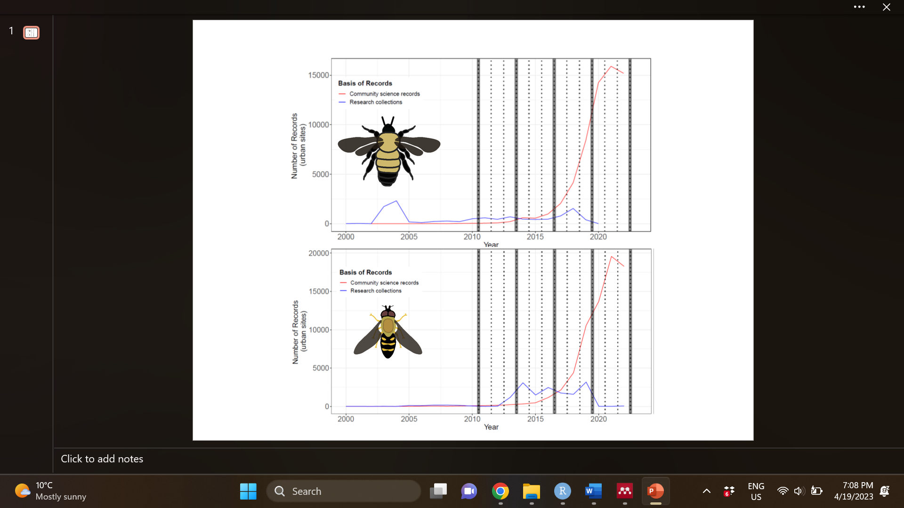**Figure 2:** Total number of detections in urban landscape sites from 2000 – 2022, for bumble bees (A) and hoverflies (B). Community science sampling trends are shown in red and research collection trends in blue. Temporal definitions of occupancy intervals are illustrated by solid grey lines, with each interval divided into 3 repeated year-long survey periods illustrated by dashed grey lines. Note that we further filtered the NHC data to include only unique combinations of species/site/year representing binary detection/non-detections.

1. ***Results***

Word count: 619

Across all bumble bee species included, there is not a significant association between the area of natural habitat in the urban landscape and landscape-scale occupancy rate ( $μ_{Ψ_{habitat}}$ = , 95% BCI = [ , ], figure 3a; supplemental figure 18). However, species-specific associations varied widely ( $σ_{Ψ_{habitat}}$ = , 95% BCI = [ , ]), with some species having a significant positive association with natural habitat area (e.g., *B. perplexus*, 95% BCI = [ , ]) and others having a significant negative association with natural habitat area (e.g., *B. auricomus*, 95% BCI = [ , ]) (figure 3a, table 1). Our model output provides weak certainty that community-wide bumble bee occupancy rate increases with income ( $μ_{Ψ_{income}}$ = , 50% BCI = [ , ]; but 95% BCI = [ , ], figure 3a; supplemental figure 19). Species-specific responses to income were relatively less variable ( $σ_{Ψ_{income}}$ = , 95% BCI = [ , ]).

In contrast to bumble bees, community-wide hoverfly occupancy is higher in urban landscapes with more natural habitat area (figure 3b; supplemental figure 20). Again, species varied widely in their association with natural habitat area ( $σ_{Ψ_{habitat}}$ = , 95% BCI = [ , ]) with some species having a very strong association with natural habitat area (e.g., *Copestylum avidum*, 95% BCI = [ , ]) while others have an uncertain or negative association (e.g., *Eoseristalis arbustorum*, 95% BCI = [ , ]) (supplemental table 3).

For both taxonomic groups, community science detection rates increased exponentially through time (for bumble bees: $p_{interval}^{cs}$ = , 95% BCI = [ , ]; for hoverflies: $p_{interval}^{cs}$ = , 95% BCI = [ , ]) and in areas with higher population density ( $p_{pop density}^{cs}$ = , 95% BCI = [ , ] for bumble bees; $p_{pop density}^{cs}$ = , 95% BCI = [ , ] for hoverflies) (figures 3c and 3d).

For both taxonomic groups, there is no correlation between species rarity and the species-specific effect of natural habitat area on urban landscape occupancy – for bumble bees: mean Pearson correlation coefficient = , 95% distribution following propagation of uncertainty = [ , ]; for hoverflies: mean Pearson correlation coefficient = , 95% distribution following propagation of uncertainty = [ , ] (supplemental figures 21 and 22).

FTP’s between 0.05 and 0.95 for all bumble bee species for both the community science dataset and for the research collection dataset (table 1) indicate reasonable goodness of fit (Conn et al., 2018). For hoverflies, FTP’s for the community science dataset are consistently between 0.05 and 0.95 (supplemental table 3). However, FTP’s for the research collection dataset are below < 0.05 for several species (can provide specific numbers here?) (supplemental table 3). All of these species with lack of model fit are species that were only detected via the community science observation process and never by the research collection observation process.

Sensitivity analyses indicate that the results are not significantly affected by the choice of temporal division of the data: for bumble bees, the 95% BCI for the association between occupancy and natural habitat area is 0 for all temporal division scenarios (supplemental table 4), or for hoverflies, the 95% BCI for the association between occupancy and natural habitat area remains consistently greater than 0 for all temporal division scenarios (supplemental table 5). On the other hand, the occupancy intercept increases while the magnitude of the association between occupancy and natural habitat area or income diminishes as site grain size increases (table 2). For hoverflies, the 95% BCI for the association between occupancy and natural habitat area ranges from [ , ] (10 km grid cell edge lengths), [ , ] (15 km), [ , ] (20 km) and [ , ] (25 km) (table 2). For bumble bees, the 95% BCI for the association between occupancy and income ranges from [ , ] (10 km grid cell edge lengths), [ , ] (15 km), [ , ] (20 km) and [ , ] (25 km) (table 2; supplemental table 6).

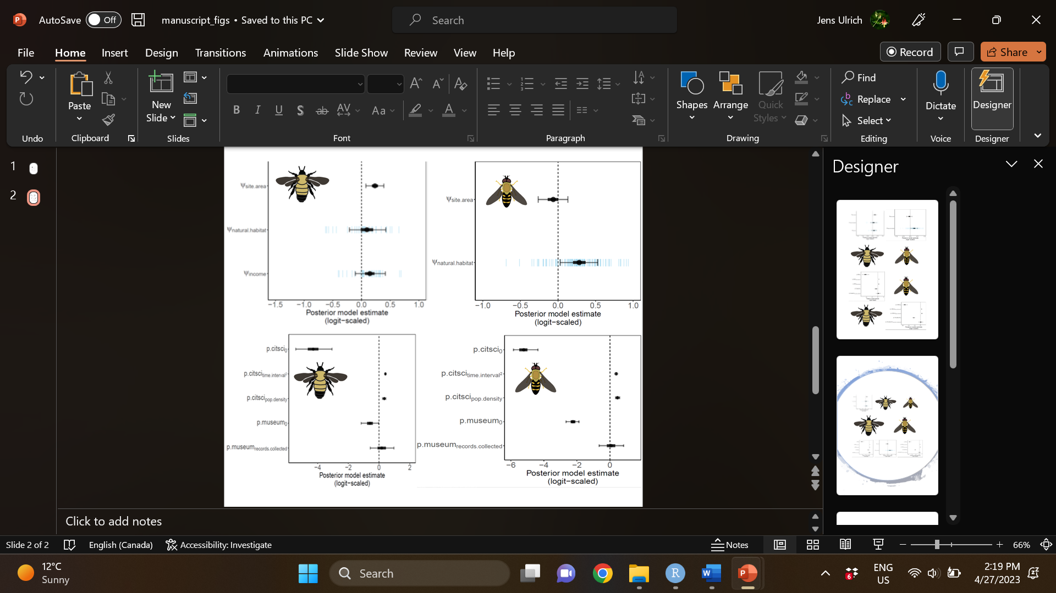

Figure 3: (logit-scaled) Posterior estimates for bumble bee occupancy parameters (a), hoverfly occupancy parameters (b), bumble bee detection parameters (c) and hoverfly detection parameters (d). Filled circles indicate posterior means, with uncertainty in the magnitude of the association conveyed by 50% (heavy band) and 95% (thin band) BCI. Blue dashes indicate mean values for species-specific random effects; n species = 32 (bumble bees) and 126 (hoverflies).



**Table 1:** (95% BCI’s) for bumble bee species-specific occupancy estimates intercepts (column 1), association with income (column 2) and association with natural habitat area (column 3). Species specific Freeman-Tukey P value (FTP) discrepancy measures describe the goodness of fit of the model for the community science (column 4) and research collections (column 5) data, with values > 0.95 indicating model overfitting and values < 0.05 indicating model underfitting.

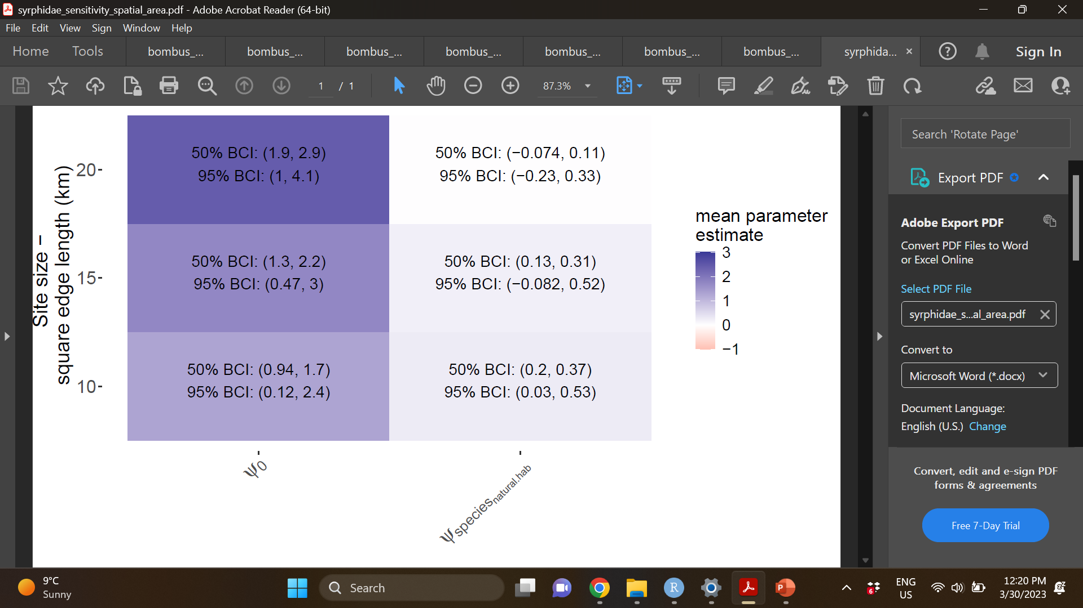

**Table 2:** Spatial grain sensitivity analysis (hoverflies)

1. ***Discussion***

Word count: ~1,400 + 1,575 + 609 = 3,575

While previous studies have identified drivers of locally observed urban pollinator biodiversity, to our knowledge this is the first study to use an across city comparison to test whether two proxies for pollinator habitat (natural area and income) predict long-term, landscape scale urban pollinator biodiversity patterns. Individual bumble bee species showed wide variation in their responses to natural habitat area in the urban landscape (table 1), however, our results indicate that the occupancy rate of the average bumble bee species does not have a strong association with total natural habitat area (figure 3a). On the other hand, we identified weak certainty in a positive association between bumble bee occupancy rates and the relative income of an urban landscape (a proxy measure for plant diversity and vegetation management resources (Leong et al., 2018)) (figure 3a), highlighting that investment in management of the vegetation in the matrix of the anthropogenic landscape itself, separate from inclusion of large areas of undeveloped habitat, is a key component of urban pollinator conservation. Interestingly, we found a different pattern for hoverflies, with hoverflies exhibiting a positive association between total natural habitat area and landscape-scale occupancy, but no association with income (figure 3b). This result emphasizes that natural habitat remnants such as urban greenbelts and nature reserves remain essential for certain pollinator taxa to persist. Together, our results demonstrate that drivers of local pollinator abundance and diversity also operate at larger spatial scales, mediating long-term trends in landscape-scale urban pollinator occupancy – although with different drivers and varying effect sizes among different species and taxonomic groups. We discuss the assumptions and limitations of our results as well as their implications for urban biodiversity conservation applications and, moreover, for our understanding of the spatiotemporal scale dependence of biodiversity patterns.

City-wide features are hypothesized to act as an intermediate filter that link local and regional biodiversity (Aronson et al., 2016). While local pollinator species richness may increase with urban natural park size (Faeth & Kane, 1978; Beninde et al., 2015) or in more affluent neighborhoods (Baldock et al., 2019), few studies have compared among multiple cities to test whether the urban landscape context (e.g., total natural habitat area or distribution of resources across the urban matrix) mediates whether species are present (Aronson et al., 2016; Magle et al., 2019). Looking at over 400 urban landscape replicates from across the continental U.S., we found that differences among urban landscapes influence landscape scale pollinator species occupancy (figure 3a and 3b). Agreeing with among city comparisons of bird and plant (Aronson et al., 2014) and mammal (Fidino et al., 2021) biodiversity, our results reinforce that city context acts as a preliminary filter that precedes the processes governing local population dynamics and community assembly (Aronson et al., 2016). The temporal span of our data (12 years) strengthens the argument that city context drives long-term species occupancy rather than temporary changes due to movement or redistribution of organisms in the landscape following habitat changes (Tscharntke et al., 2012).

Mechanistically, the landscape scale filtering process found here and in other multi-city studies (Aronson et al., 2014; Fidino et al., 2021) may function by impacting metapopulation and metacommunity dynamics – for example, cities with more natural habitat area may have higher hoverfly occupancy because subpopulations in some natural habitat patches recolonize other natural habitat patches following stochastic local extinctions (Hanski, 1999; Leibold et al., 2004, Chase et al., 2020). Alternatively, the quality of the habitat perceived by an individual organism – including food diversity (Nielsen et al., 2014) or climate moderation (Spronken-Smith & Oke, 1998, Zhang et al., 2009) – is shown to scale with the total availability of habitat in the landscape, potentially driving higher occupancy rates in cities with more natural habitat. Natural habitat area also positively predicts microhabitat heterogeneity, potentially increasing the likelihood that microhabitat requirements for specialized species are met in cities that harbour more habitat area (Ouin et al., 2006).

We found disagreement between pollinator group responses to natural habitat area: a significant positive association for the average hoverfly species (figure 3b), but no evidence of an association for the average bumble bee species (figure 3a). This emphasizes that some pollinator groups are more sensitive than others to the intensity of urban land use change. These contrasting landscape scale responses of hoverflies versus bumble bees parallel with several other studies that find contrasting local scale responses to urbanization intensity: Local bee abundance and diversity may be maintained (Verboven et al., 2014) or decline only marginally (Bates et al., 2011) along urbanization gradients where hoverflies decline significantly. In other cases, local bee abundance and diversity increases along an urbanization gradient while hoverflies decline (Baldock et al., 2015) or remain stable (Deguines et al., 2012; Theodorou et al., 2020). Studies focusing specifically on bumble bees find either no association (McFrederick & LeBuhn, 2006; Ahrne et al., 2009; Reeher et al., 2020) or a positive association (Novotny et al., 2021) between local abundance and diversity and the proportion of heavily developed urban land. It has been argued that hoverflies are *less* susceptible to land use change versus wild bees (Jauker et al., 2009; Aguirre-Gutierrez et al., 2015; Jauker et al., 2018), however, these claims have been made in the context of agricultural landscape simplification. The discrepancy in responses to agricultural versus urban land use change implies that these different forms of anthropogenic habitat modification uniquely drive biodiversity patterns. We hypothesize that hoverflies versus bumble bees could be more susceptible to the unique drivers associated with urbanization.

Unlike agricultural land use change, urban land use change is associated with elevated temperature (Oke, 1982). Urban natural parks provide refuge from urban warming, with cooling effects extending into the surrounding urban matrix (Bowler et al., 2010). Hoverflies lack water retention systems and so they may desiccate more easily than other insects in hot, dry conditions (Skevington et al., 2019), potentially underlying more limited population stability in urban landscapes with decreased natural habitat driven temperature moderation. Conversely, some bumble bee species may be associated with increasing temperatures (Jackson et al., 2022) and so on average this group not be as dependent on the cooling features provided by natural parks. Further comparative physiological work (similar to Hamblin et al., 2018) comparing thermal performance among different pollinator guilds would help to better understand whether this mechanism contributes to these disparate responses.

Additionally, larval life history differences could also underlie contrasting responses to natural habitat area. Many bumble bees construct nests in abandoned rodent burrows (Williams et al., 2014; Varner et al., 2023), which proliferate in urban systems due to urban rodent commensalism (Banks & Smith, 2015; Blasdell et al., 2022), and where bumble bee nesting densities positively correlate with the number of rodent burrows in a city (McFrederick & LeBuhn, 2006). As such, the average bumble bee species may have sufficient opportunity to nest in the urban landscape matrix outside of the natural areas captured in our metric. Although the bumble bee nesting densities increase from proximity to natural areas (Kremen & Jha, 2013b; Confliti et al., 2022), the increase in the number of nests could be too small to translate into landscape-scale species persistence (as is observed here) if landscape-scale demography is relatively elastic to nest establishment. In contrast to bees, hoverflies do not maintain fixed nest positions, but rather broadcast eggs in targeted locations that then develop into free-living larvae (Skevington et al., 2019). Larval life histories (and the habitat requirements needed to sustain these life histories) are highly diverse and include: terrestrial larvae that live on plants and consume soft bodied insects; bacterial filter feeders living in ponds, lagoons, sap runs, tree holes, bromeliads, decaying plant matter or other bodies of water; kleptoparasites in ant or bee nests; and plant, fungal and heartwood feeders (Skevington et al., 2019). Microhabitat heterogeneity increases with size of a forest patch embedded in an anthropogenic landscape corresponding with increasing hoverfly species richness (Ouin et al., 2006). Larger amounts of natural habitat in an urban landscape may also translate into increased microhabitat heterogeneity that fulfills specialized larval life histories of a higher proportion of species.

Other insect pollinator groups including butterflies and beetles are more sensitive to local urbanization intensity than hoverflies or wild bees (Deguines et al., 2012; Fenoglio et al., 2020; Theodorou et al., 2020). If these pollinator group differences hold at the larger spatial scales examined here, then maintaining natural habitat remnants in the urban landscape should be even more critical for these pollinators. Further, because ee species with narrow diet breadths and limited dispersal are most strongly affected by land use intensity and change (Bommarco et al., 2010), other wild bee species versus bumble bees may be more sensitive to the amount of natural habitat area within an urban landscape. Although bumble bees vary in diet breadth (Wood et al., 2019), none of the bumble bees in our study exhibit extreme diet specialization at or below the level of plant family level (Richardson, 2022) contrasting with other wild bees (Danforth et al., _). Bumble bee dispersal capabilities are also likely to be relatively large given their larger body sizes (Greenleaf et al., 2007). Therefore, we expect bumble bees to be more conservative indicators of land use change compared to other wild bees.

Although the community mean associations between natural habitat area and landscape scale occupancy are positive (hoverflies) or negligible (bumble bees), there is significant variation among species within each group (bumble bees - table 1, hoverflies - supplementary table _). Some bumble bee species appear significantly more likely to occur in urban landscapes within their range when there is more natural habitat (95% BCI > 0), specifically: *B. perplexus*, *B. huntii*, *B. fervidus* and *B****.*** *crotchii*. In the midwestern U.S, both *B. perplexus* and *B. fervidus* are declining species (Wood et al., 2019) that are more likely than other bumble bee species to be associated with forested landscapes (Novotny et al., 2021). Both species have narrower than average dietary breadths (Wood et al., 2019), and in particular, B. perplexus appears to have the highest foraging preference for woody species (trees and shrubs) versus any other bumble bee species in this region (Wood et al., 2019), which aligns with lower success in cities which are typically dominated by more open habitat types (Baldock et al., 2020). The endangered and declining *B. crotchii* (a species endemic to California) (Hatfield et al., 2014; Fisher et al., 2022), has been detected in semi-natural grassland and scrubland within heavily developed landscapes (Love, 2010). Our results suggest that is likely to disappear from Californian cities if these natural habitat remnants are removed from the urban landscape. Although hoverflies on average show a positive association with natural habitat patches, some species appear to require these areas to persist in the urban landscape significantly more so than others. These include… (a few sentences about the most extreme and why that might be). Are there any hoverflies that are classified as imperiled/endangered?

Both taxonomic groups include species that are more likely to be present when there is less natural habitat (bumble bees - table 1, hoverflies - supplementary table _). These parallel other more well-studied species (e.g., raccoon (*Procyon lotor*), gray squirrel (*Sciurus carolinensis*), house finch (*Haemorhous mexicanus*) or northern cardinal (*Cardinalis cardinalis*)) that are known to exploit anthropogenic resources available in urban areas (Rodewald & Gehrt, 2014). These urban exploiters typically have generalized ecological niches with flexible behavior that allows exploitation of food and shelter that humans provide (Rodewald & Gehrt, 2014). We did not find any correlation between rarity (defined as habitat specialization and quantified as the range wide occupancy, including in non-urban landscapes) and association with natural habitat area for bumble bees or for hoverflies (supplemental figures 22 and 23). Driving this lack of correlation, we found that both widespread (e.g., *B. auricomus*) and more narrowly restricted (e.g., *B. citrinus*) species are simultaneously especially associated with highly developed urban landscapes (table 1). The bumble bee species most associated with more highly developed urban landscapes are all of lesser conservation concern (*B. citrinus*, *B. auricomus*, *B. vagans*) (Hatfield et al., 2014). Similarly, many hoverfly species associated with more highly developed urban landscapes are non native (*Eoseristalis arbustorum*, *Eristalis tenax*, …). Thus, highly developed urban landscapes may be providing refuge for some pollinator species (Hall et al., 2017), but not necessarily those of highest conservation need.

The association between landscape-scale natural habitat area and landscape-scale pollinator occupancy suggests that coordinated, city-wide action and design plans are necessary to conserve optimum pollinator biodiversity. Small, independent urban pollinator habitat amendments alone may not sustain pollinator species if they are embedded in an urban landscape that precludes species from the regional species pool (Tscharntke et al., 2012; Aronson et al., 2016, Chase et al., 2020). In practice, projected growth of urban populations (Simkin et al., 2022) means that new natural habitat areas such as urban greenbelts and natural reserves are unlikely to be established in older cities that are already heavily developed. Given the results here, we recommend a) that existing natural habitat remnants are protected, and b) that expanding urban centers develop with plans to include nature parks embedded within the urban landscape. For example, in Ottawa (Ontario, Canada) newly announced urban development plans include converting 7,400 acres of urban green belt for residential use (Legislative Assembly of Ontario, 2022). An alternative plan would be to densify the existing developed urban land both inside and outside of the Ottawa greenbelt. This may reduce area for low-density single-family home zoning but would act to maintain natural habit areas necessary to maintain pollinator biodiversity conservation in the city (figure 3b) as well as human access to the ecosystem services provided by direct access to the greenspace (Reyes et al., 2021) and of pollination services provided by the pollinators relying on this greenspace. While city-wide planning may be needed to conserve landscape-scale urban pollinator biodiversity, we recognize the value of small habitat amendments for local education and access to nature (Turo & Gardiner, 2019) and, further, that as their area within a city increases (by expanding across private residences and within developed land cover) that their contributions to pollinator conservation may overtake those of large public natural areas.

After accounting for total natural habitat area, our results indicate weak certainty in a positive association between income and landscape scale bumble bee occupancy (figure 3a). We used income as a proxy measure for resources that may translate into increased plant diversity, which we justify given the correspondence found in many urban ecology studies (Leong et al., 2018). This association between income and plant diversity may arise directly (i.e., individuals have more disposable income to invest in maintaining diverse plants on their private properties), indirectly (i.e., individuals with more income have more political or social power to lobby for public amenities including improved vegetation management in their neighborhoods) or as a corollary with other socioeconomic variables (i.e., people with more income may also have obtained a higher education level including education that raises awareness about widespread pollinator declines and the value of flower resources for mitigating these declines) (Leong et al., 2018). Regardless of the mechanism leading to the weak luxury effect observed here, our results highlight that management of the urban matrix itself, outside of the preservation of natural habitat remnants, mediates pollinator occupancy. This agrees with other key studies that show that matrix quality matters for biodiversity conservation, providing increased area for non-specialist species to persist and/or reducing the hostility of environment interceding habitat patches (Ricketts, 2001; Prugh et al., 2008; Franklin & Lindenmeyer, 2009; Driscoll et al., 2013). As such (and given the inability to increase natural habitat areas in urban landscape undergoing continued urban development as discussed above), a key goal for future urban pollinator biodiversity conservation should be to invest in neighborhood features that enhance the quality of the urban landscape matrix. A socially-just goal would be to prioritize these resources towards less affluent neighborhoods (evening out the luxury effect trend we observed here) (Leong et al., 2018). This would act to simultaneously reduce pollinator biodiversity disparity among landscapes and also promote equal benefit from the ecosystem services provided by these pollinators. Even if common species are already present in urban landscapes, increasing total species occurrence should continue to improve ecosystem services delivery because rare species contribute disproportionately to ecosystem function (Letaio et al., 2018).

Here we use occupancy as a surrogate for demographic trends, representing the equilibrium between landscape scale extinction and colonization (MacKenzie & Nichols, 2004). Binary occupancy states are information-poor summaries of abundance that may fail to capture long-term demographic trends if extinctions at unfavourable sites are slow to unfold (Kery & Royle, 2020). As such, our results may be conservative underestimates of the importance of natural habitat area or income mediated plant management if pollinator populations in unfavourable landscapes are declining but have not yet reached full landscape scale extinctions. Because species richness is the sum of species occurring in a spatial unit, the occupancy metric used here can also be extrapolated to make statements about diversity (Kery & Royle, 2020). That is, because hoverfly species occupancy increases in urban landscapes (within the species range) that harbour more natural habitat area, we can also infer that hoverfly species richness (relative to the regional species pool) increases. Our model outputs indicate lack of goodness of fit for some species. As opposed to a more traditional approach of conducting a posterior predictive check for our full dataset/s (Conn et al., 2018; Doser et al., 2022), we binned our data within each dataset by species identity, aiming to better understand where the model performs well and where the model under/overpredicts real detections. We found good fit of the model for the community science dataset (where our model reasonably predicts observed detections), but generally poor fit for the research collections data set whenever a species was never detected in that dataset (with this mismatch only occurring for the more data sparse hoverflies) (supplemental table 3). Using data simulation, we created similar scenarios with rich community science detections and sparse research collections detections generated from a known underlying ecological process. We found that the underlying ecological parameters are accurately returned despite some species in the research collections dataset indicating serial lack of fit (supplemental figures 23 and 24). Goodness of fit evaluation for integrated models is an active area of research where further insights might help to develop improved rules of thumb for assessing model predictive performance (Fletcher et al., 2019; Doser et al., 2022).

We note that the effects of natural habitat area and income on pollinator occupancy diminish as spatial scale increases. For example, at a 10 km $×$ 10 km spatial grain the total natural habitat area affects hoverfly occupancy but at 25 km $×$ 25 km the effect size and its associated uncertainty drop towards zero (table 2). This well-established pattern of scale dependency may potentially arise if broader scale habitat selection (due to temperature, precipitation, elevation, etc.) overrides the effects of a city’s habitat composition or potentially if larger spatial grains contain environmental variation that is no longer experienced by a population due to movement and dispersal constraints (Wiens, 1989; Rahbek, 2004). The results of the sensitivity analysis suggest that conservation action taken in individual city landscapes (~10 km $×$ 10 km) can have an appreciable impact on pollinator biodiversity regardless of actions in a surrounding metropolitan area. The spatial scale at which urban biodiversity conservation action and planning will mediate landscape scale biodiversity is likely to vary for other functional groups such as birds or mammals because they typically experience the environment at broader spatial scales than insects (Wiens, 1989).

Community science NHC’s provided the bulk of evidence used to make inferences about landscape-scale urban biodiversity (figure 2). Here we build on a framework for integrating these data with research collections (Davis et al., 2022), anchoring our inference of true presence/absence using research collections NHC’s while expanding the spatiotemporal scope of our analysis using the widespread detection/non-detections provided by community science efforts. Our novel approach to comparing multi-city data confronts potential detection biases (as opposed to Aronson et al., 2014) and overcomes logistical difficulties that would be involved with estimating multi-city insect population trends using passive sampling methods developed for larger wildlife species (i.e., camera traps used for mammals, Fidino et al., 2021). The increasing overall number of records (figure 2) and increase in detection rates through time (figures 3c and 3d) provide an optimistic outlook for future opportunities to test more nuanced hypotheses using this framework that require richer data sources. Given the positive effect of population density on detection rate (figures 3c and 3d) community science data should be particularly useful for future ecological studies in urban systems.

Much of urban ecology and conservation science, and ecology generally, is focused on quantifying biodiversity metrics at a local scale, assuming that local populations and communities are spatially closed and isolated (Leibold et al., 2004; Chase et al., 2020). With this study we examined relationships between the environment and species occupancy at multiple broader spatial scales to test the hypothesis that the urban landscape quality mediates urban landscape pollinator biodiversity. For hoverflies, urban landscapes with larger amounts of natural habitat area populations, while for bumble bees, affluent urban landscapes with presumably more resources to invest in vegetation cover and management – including in the developed urban matrix itself – sustain more species. Thus, the fate of a species in the landscape is mediated not just by local urban development but also by the broader city context. The conclusions from this cross-landscape analysis call for increased consideration of the interplay between local population and community dynamics with landscape to regional dynamics. In application, this demands that local urban habitat restoration and enhancements coordinate with city-wide policy and planning to ensure long-term success of species conservation.

***References***

~ 3,000 (should aim to reduce citations – need to update this list anyways and do formatting)

Adams, B. J., Li, E., Bahlai, C. A., Meineke, E. K., McGlynn, T. P., & Brown, B. V. (2020). Local‐and landscape‐scale variables shape insect diversity in an urban biodiversity hot spot. Ecological Applications, 30(4), e02089.

Ahrné, K., J. Bengtsson, and T. Elmqvist. 2009. Bumble bees (Bombus spp) along a gradient of increasing urbanization. PLoS ONE 4:e5574.

Aizen, M. A., Smith‐Ramírez, C., Morales, C. L., Vieli, L., Sáez, A., Barahona‐Segovia, R. M., ... & Harder, L. D. (2019). Coordinated species importation policies are needed to reduce serious invasions globally: The case of alien bumblebees in South America. Journal of Applied Ecology, 56(1), 100-106.

Aronson, M. F. J. et al 2014. A global analysis of the impacts of urbanization on bird and plant diversity reveals key anthropogenic drivers. Proceedings of the Royal Society B 281:20133330.

Baldock, K. C., Goddard, M. A., Hicks, D. M., Kunin, W. E., Mitschunas, N., Osgathorpe, L. M., ... & Memmott, J. (2015). Where is the UK's pollinator biodiversity? The importance of urban areas for flower-visiting insects. Proceedings of the Royal Society B: Biological Sciences, 282(1803), 20142849.

Baldock, K. C., Goddard, M. A., Hicks, D. M., Kunin, W. E., Mitschunas, N., Morse, H., ... & Memmott, J. (2019). A systems approach reveals urban pollinator hotspots and conservation opportunities. Nature ecology & evolution, 3(3), 363-373.

Baldock, K. C. (2020). Opportunities and threats for pollinator conservation in global towns and cities. Current opinion in insect science, 38, 63-71.

Banaszak-Cibicka, W., & Żmihorski, M. (2012). Wild bees along an urban gradient: winners and losers. Journal of Insect Conservation, 16, 331-343.

P. B. Banks, H. M. Smith, The ecological impacts of commensal species: Black rats, Rattus rattus, at the urban–bushland interface. Wildl. Res. 42, 86–97 (2015).

Blasdell, K. R., Morand, S., Laurance, S. G., Doggett, S. L., Hahs, A., Trinh, K., ... & Firth, C. (2022). Rats and the city: Implications of urbanization on zoonotic disease risk in Southeast Asia. Proceedings of the National Academy of Sciences, 119(39), e2112341119.

Beduschi, T., Kormann, U.G., Tscharntke, T., and Scherber (2018). Spatial community turnover of pollinators is relaxed by semi-natural habitats, but not by mass-flowering crops in agricultural landscapes. Biol. Conserv. 221, 59–66. doi: 10.1016/j.biocon.2018.01.016

Bommarco, R., J. C. Biesmeijer, B. Meyer, S. G. Potts, J. Poyry, S. P. M. Roberts, I. Steffan-Dewenter, and E. Öckinger. 2010. Dispersal capacity and diet breadth modify the response of wild bees to habitat loss. Proceedings of the Royal Society B 277:2075–2082.

Botı´as C, David A, Horwood J, Abdul-Sada A, Nicholls E, Hill E, Goulson D: Neonicotinoid residues in wildflowers, a potential route of chronic exposure for bees. Environ Sci Technol 2015, 49:12731-12740.

Bowler, D. E., Buyung-Ali, L., Knight, T. M., & Pullin, A. S. (2010). Urban greening to cool towns and cities: A systematic review of the empirical evidence. Landscape and urban planning, 97(3), 147-155.

Brittain, C. A., Vighi, M., Bommarco, R., Settele, J., & Potts, S. G. (2010). Impacts of a pesticide on pollinator species richness at different spatial scales. Basic and Applied Ecology, 11(2), 106-115.

Carpenter, B., Gelman, A., Hoffman, M. D., Lee, D., Goodrich, B., Betancourt, M., ... & Riddell, A. (2017). Stan: A probabilistic programming language. Journal of statistical software, 76(1).

Casanelles‐Abella, J., Müller, S., Keller, A., Aleixo, C., Alós Orti, M., Chiron, F., ... & Moretti, M. (2022). How wild bees find a way in European cities: Pollen metabarcoding unravels multiple feeding strategies and their effects on distribution patterns in four wild bee species. Journal of Applied Ecology, 59(2), 457-470.

Colla SR, Otterstatter MC, Gegear RJ, Thomson JD (2006) Plight of the bumble bee: pathogen spillover from commercial to wild populations. Biol Conserv 129:461–467

Conflitti, I. M., Arshad Imrit, M., Morrison, B., Sharma, S., Colla, S. R., & Zayed, A. (2022). Bees in the six: Determinants of bumblebee habitat quality in urban landscapes. Ecology and Evolution, 12(3), e8667.

Cook EM, Hall SJ, Larson KL: Residential landscapes as social- ecological systems: a synthesis of multi-scalar interactions between people and their home environment. Urban Ecosyst 2012, 15:19-52.

Cheptou, P. O., & Avendaño V, L. G. (2006). Pollination processes and the Allee effect in highly fragmented populations: consequences for the mating system in urban environments. New Phytologist, 172(4), 774-783.

Davis, A. Y., Lonsdorf, E. V., Shierk, C. R., Matteson, K. C., Taylor, J. R., Lovell, S. T., & Minor, E. S. (2017). Enhancing pollination supply in an urban ecosystem through landscape modifications. Landscape and Urban Planning, 162, 157-166.

Deguines, N., Julliard, R., De Flores, M., & Fontaine, C. (2012). The whereabouts of flower visitors: contrasting land-use preferences revealed by a country-wide survey based on citizen science.

Dorazio, R. M., Royle, J. A., Söderström, B., & Glimskär, A. (2006). Estimating species richness and accumulation by modeling species occurrence and detectability. Ecology 87(4), 842-854.

Doser, J. W., Leuenberger, W., Sillett, T. S., Hallworth, M. T., & Zipkin, E. F. (2022). Integrated community occupancy models: A framework to assess occurrence and biodiversity dynamics using multiple data sources. Methods in Ecology and Evolution, 13(4), 919-932.

Douglas, M. R., Baisley, P., Soba, S., Kammerer, M., Lonsdorf, E. V., & Grozinger, C. M. (2022). Putting pesticides on the map for pollinator research and conservation. Scientific Data, 9(1), 571.

Doyle, T., Hawkes, W. L., Massy, R., Powney, G. D., Menz, M. H., & Wotton, K. R. (2020). Pollination by hoverflies in the Anthropocene. Proceedings of the Royal Society B, 287(1927), 20200508.

Faeth, S. H., & Kane, T. C. (1978). Urban biogeography: city parks as islands for Diptera and Coleoptera. Oecologia, 32, 127-133.

Fenoglio, M. S., Rossetti, M. R., & Videla, M. (2020). Negative effects of urbanization on terrestrial arthropod communities: A meta‐analysis. Global Ecology and Biogeography, 29(8), 1412-1429.

Fidino, M., Gallo, T., Lehrer, E. W., Murray, M. H., Kay, C. A., Sander, H. A., ... & Magle, S. B. (2021). Landscape‐scale differences among cities alter common species’ responses to urbanization. Ecological Applications, 31(2), e02253.

Fisher, K., Watrous, K. M., Williams, N. M., Richardson, L. L., & Woodard, S. H. (2022). A contemporary survey of bumble bee diversity across the state of California. Ecology and Evolution, 12(3), e8505.

Fitch, G., Wilson, C. J., Glaum, P., Vaidya, C., Simao, M. C., & Jamieson, M. A. (2019). Does urbanization favour exotic bee species? Implications for the conservation of native bees in cities. Biology letters, 15(12), 20190574.

Fletcher, R. J., Hefley, T. J., Robertson, E. P., Zuckerberg, B., McCleery, R. A., & Dorazio, R. M. (2019). A practical guide for combining data to model species distributions. Ecology, 100(6), e02710.

Fürst, M. A., McMahon, D. P., Osborne, J. L., Paxton, R. J., & Brown, M. J. F. (2014). Disease associations between honeybees and bumblebees as a threat to wild pollinators. Nature, 506(7488), 364-366.

Gelman, A., and Hill, J. (2007). Data Analysis Using Regression and Multilevel/Hierarchical Models. New york, NY: Cambridge University Press. doi: 10.1017/CBO9780511790942

Gledhill DG, James P. 2012 Socio-economic variables as indicators of pond conservation value in an urban landscape. Urban Ecosyst. 15, 849–861. (doi:10. 1007/s11252-012-0242-7)

Gonzales, D., Hempel de Ibarra, N., & Anderson, K. (2022). Remote Sensing of Floral Resources for Pollinators–New Horizons From Satellites to Drones. Frontiers in Ecology and Evolution, 10.

Grimm, N. B., S. H. Faeth, N. E. Golubiewski, C. L. Redman, J. Wu, X. Bai, and J. M. Briggs. 2008. Global change and the ecology of cities. Science 319:756–760.

Grossmann, A. J., Herrmann, J., Buchholz, S., & Gathof, A. K. (2022). Dry grassland within the urban matrix acts as favourable habitat for different pollinators including endangered species. Insect Conservation and Diversity.

Hall, D. M., Camilo, G. R., Tonietto, R. K., Ollerton, J., Ahrné, K., Arduser, M., ... & Threlfall, C. G. (2017). The city as a refuge for insect pollinators. Conservation Biology, 31(1), 24-29.

Hamblin, A. L., Youngsteadt, E., & Frank, S. D. (2018). Wild bee abundance declines with urban warming, regardless of floral density. Urban Ecosystems, 21, 419-428.

Harrison, T., Gibbs, J., & Winfree, R. (2018). Forest bees are replaced in agricultural and urban landscapes by native species with different phenologies and life‐history traits. Global Change Biology, 24(1), 287-296.

Harrison, T., Gibbs, J., & Winfree, R. (2019). Anthropogenic landscapes support fewer rare bee species. Landscape Ecology, 34, 967-978.

Hatfield, R., Colla, S., Jepsen, S., Richardson, L., Thorp, R., & Jordan, S. F. (2014). IUCN assessments for North American Bombus spp. technical report for the North American IUCN Bumble Bee Specialist Group. Assessments completed 2014, document updated in February 2015. (56 pp).

Hope D, Gries C, Zhu WX, Fagan WF, Redman CL, Grimm NB, Nelson AL, Martin C, Kinzig A. 2003 Socioeconomics drive urban plant diversity. Proc. Natl Acad. Sci. USA 100, 8788–8792. (doi:10.1073/ pnas.1537557100)

Jauker, F., & Wolters, V. (2008). Hover flies are efficient pollinators of oilseed rape. Oecologia, 156, 819-823.

Jha, S., Egerer, M., Bichier, P., Cohen, H., Liere, H., Lin, B., ... & Philpott, S. M. (2023). Multiple ecosystem service synergies and landscape mediation of biodiversity within urban agroecosystems. Ecology Letters, 26(3), 369-383.

Jha, S., & Kremen, C. (2013a). Resource diversity and landscape-level homogeneity drive native bee foraging. Proceedings of the National Academy of Sciences of the United States of America, 110, 555–558. https://doi.org/10.1073/pnas.1208682110

Jha, S., & Kremen, C. (2013b). Urban land use limits regional bumble bee gene flow. Molecular Ecology, 22, 2483–2495 https://doi.org/10.1111/mec.12275.

Kerr, J.T. & Cihlar, J. (2003). Land use and cover with intensity of agriculture for Canada from satellite and census data. Global Ecol. Biogeogr., 12, 161 – 172.

Kéry, M., & Royle, J. A. (2020). Applied hierarchical modeling in ecology: Analysis of distribution, abundance and species richness in R and BUGS: Volume 2: Dynamic and advanced models. Academic Press.

Klein Goldewijk, K. 2001 Estimating global land use change over the past 300 years: the HYDE database. Global Biogeochem. Cycles 15, 417–433.

Klein, A. M., Vaissière, B. E., Cane, J. H., Steffan-Dewenter, I., Cunningham, S. A., Kremen, C., & Tscharntke, T. (2007). Importance of pollinators in changing landscapes for world crops. Proceedings of the royal society B: biological sciences, 274(1608), 303-313.

Koh, I., Lonsdorf, E. V., Williams, N. M., Brittain, C., Isaacs, R., Gibbs, J., & Ricketts, T. H. (2016). Modeling the status, trends, and impacts of wild bee abundance in the United States. Proceedings of the National Academy of Sciences, 113(1), 140-145.

Kovacs-Hostyanszki, A., Soltesz, Z., Szigeti, V., Somay, L., & Baldi, A. (2021). Non-rotational set-aside fields improve reproductive success of cavity-nesting bees and wasps at the landscape scale, but have no effect on other wild bees and hoverflies in mid-summer. Agriculture, Ecosystems & Environment, 308, 107255.

Legislative Assembly of Ontario. (2022). Bill 23, More Homes Built Faster Act, 2022. https://www.ola.org/en/legislative-business/bills/parliament-43/session-1/bill-23. Accessed April 24, 2023.

Leitão, R. P., J. Zuanon, S. Villéger, S. E. Williams, C. Baraloto, C. Fortunel, and D. Mouillot. 2016. “Rare Species Contribute Disproportionately to the Functional Structure of Species Assemblages.” Proceedings of the Royal Society B: Biological Sciences 283(1828): 20160084.

Lemoine, N. P. (2019). Moving beyond noninformative priors: why and how to choose weakly informative priors in Bayesian analyses. Oikos, 128(7), 912-928.

Leong, M., and Roderick, G. K. (2015). Remote sensing captures varying temporal patterns of vegetation between human-altered and natural landscapes. Peerj. 3:e1141. doi: 10.7717/peerj.1141

Leong M, Bertone MA, Bayless KM, Dunn RR, Trautwein MD. 2016 Exoskeletons and economics: indoor arthropod diversity increases in affluent neighbourhoods. Biol. Lett. 12, 20160322. (doi:10. 1098/rsbl.2016.0322)

Lin, B. B., Philpott, S. M., & Jha, S. (2015). The future of urban agriculture and biodiversity-ecosystem services: Challenges and next steps. Basic and applied ecology, 16(3), 189-201.

Lizée, M. H., Manel, S., Mauffrey, J. F., Tatoni, T., & Deschamps-Cottin, M. (2012). Matrix configuration and patch isolation influences override the species–area relationship for urban butterfly communities. Landscape ecology, 27, 159-169.

Love, B. 2010. The bees of the American and Cosumnes rivers in Sacramento County, California: effects of land use on native bee diversity. M.S. thesis submitted to California State University, Sacramento, California. 84 pp.

MacKenzie, D. I., & Nichols, J. D. (2004). Occupancy as a surrogate for abundance estimation. Animal biodiversity and conservation, 27(1), 461-467.

Martins, K. T., Gonzalez, A., & Lechowicz, M. J. (2017). Patterns of pollinator turnover and increasing diversity associated with urban habitats. Urban Ecosystems, 20, 1359-1371.

Matteson, K. C., Grace, J. B., & Minor, E. S. (2013). Direct and indirect effects of land use on floral resources and flower‐visiting insects across an urban landscape. Oikos, 122(5), 682-694.

McDonald, R. I., Biswas, T., Sachar, C., Housman, I., Boucher, T. M., Balk, D., ... & Leyk, S. (2021). The tree cover and temperature disparity in US urbanized areas: Quantifying the association with income across 5,723 communities. PloS one, 16(4), e0249715.

McFrederick, Q.S. & LeBuhn, G. (2006) Are urban parks refuges for bumble bees Bombus spp. (Hymenoptera: Apidae)? Biological Conservation, 129, 372–382.

McKinney, M. L. 2006. “Urbanization as a Major Cause of Biotic Homogenization.” Biological Conservation 127(3): 247–60.

Meehan, T. D., Werling, B. P., Landis, D. A., & Gratton, C. (2011). Agricultural landscape simplification and insecticide use in the Midwestern United States. Proceedings of the National Academy of Sciences, 108(28), 11500-11505.

Moroń, D., Lenda, M., Skórka, P., Szentgyörgyi, H., Settele, J. & Woyciechowski, M. (2009) Wild pollinator communities are negatively affected by invasion of alien goldenrods in grassland landscapes. Biological Conservation, 142, 1322–1332.

Neame, L. A., Griswold, T., & Elle, E. (2013). Pollinator nesting guilds respond differently to urban habitat fragmentation in an oak‐savannah ecosystem. Insect Conservation and Diversity, 6(1), 57-66.

Nesbitt, L., Meitner, M. J., Girling, C., Sheppard, S. R., & Lu, Y. (2019). Who has access to urban vegetation? A spatial analysis of distributional green equity in 10 US cities. Landscape and Urban Planning, 181, 51-79.

Nielsen, A. B., Van Den Bosch, M., Maruthaveeran, S., & van den Bosch, C. K. (2014). Species richness in urban parks and its drivers: A review of empirical evidence. Urban ecosystems, 17, 305-327.

Normandin E, Vereecken NJ, Buddle CM, Fournier V: Taxonomic and functional trait diversity of wild bees in different urban settings. PeerJ 2017, 5:e3051

Novotny, J. L., Reeher, P., Varvaro, M., Lybbert, A., Smith, J., Mitchell, R. J., & Goodell, K. (2021). Bumble bee species distributions and habitat associations in the Midwestern USA, a region of declining diversity. Biodiversity and Conservation, 30(3), 865-887.

Öckinger, E., Dannestam, Å., & Smith, H. G. (2009). The importance of fragmentation and habitat quality of urban grasslands for butterfly diversity. Landscape and Urban Planning, 93(1), 31-37.

Oke, T. R. 1982. The energetic basis of the urban heat island. Q. J. R. Meteorol. Soc. 108:1–24.

Oliver, T. H., Marshall, H. H., Morecroft, M. D., Brereton, T., Prudhomme, C. & Huntingford, C. (2015). Interacting effects of climate change and habitat fragmentation on drought-sensitive butterflies. Nature Climate Change 5(10), 941–945.

Ouin, A., Sarthou, J. P., Bouyjou, B., Deconchat, M., Lacombe, J. P., & Monteil, C. (2006). The species‐area relationship in the hoverfly (Diptera, Syrphidae) communities of forest fragments in southern France. Ecography, 29(2), 183-190.

Pardee GL & Philpott SM. (2014). Native plants are the bee’s knees: local and landscape predictors of bee richness and abundance in backyard gardens. Urban Ecosystems, 17:641-659.

Potts, S. G., Biesmeijer, J. C., Kremen, C., Neumann, P., Schweiger, O., & Kunin, W. E. (2010). Global pollinator declines: trends, impacts and drivers. Trends in ecology & evolution, 25(6), 345-353.

Prendergast, K. S., & Ollerton, J. (2021). Plant-pollinator networks in Australian urban bushland remnants are not structurally equivalent to those in residential gardens. Urban Ecosystems, 24(5), 973-987.

Rahbek, C. (2005). The role of spatial scale and the perception of large‐scale species‐richness patterns. Ecology letters, 8(2), 224-239.

Reeher, P., Lanterman Novotny, J., & Mitchell, R. J. (2020). Urban bumble bees are unaffected by the proportion of intensely developed land within urban environments of the industrial Midwestern USA. Urban Ecosystems, 23, 703-711.

Reyes-Riveros, R., Altamirano, A., De La Barrera, F., Rozas-Vásquez, D., Vieli, L., & Meli, P. (2021). Linking public urban green spaces and human well-being: A systematic review. Urban Forestry & Urban Greening, 61, 127105.

Richardson, L. L. 2022. Bumble bees of North America occurrence records database. https://www.leifrichardson.org/bbna.html. Data accessed 02-15-2023.

Rodewald, A. D., & Gehrt, S. D. (2014). Wildlife population dynamics in urban landscapes. Urban wildlife conservation: theory and practice, 117-147.

Roth, M., Oke, T. R., & Emery, W. J. (1989). Satellite-derived urban heat islands from three coastal cities and the utilization of such data in urban climatology. International Journal of Remote Sensing, 10(11), 1699–1720. https://doi.org/10.1080/014311689089040

Simao, M. C. M., Matthijs, J., & Perfecto, I. (2018). Experimental small‐scale flower patches increase species density but not abundance of small urban bees. Journal of applied ecology, 55(4), 1759-1768.

Simkin, R. D., Seto, K. C., McDonald, R. I., & Jetz, W. (2022). Biodiversity impacts and conservation implications of urban land expansion projected to 2050. Proceedings of the National Academy of Sciences, 119(12), e2117297119.

Sivakoff, F. S., Prajzner, S. P., & Gardiner, M. M. (2020). Urban heavy metal contamination limits bumblebee colony growth. Journal of Applied Ecology, 57(8), 1561-1569.

Spronken-Smith, R. A., & Oke, T. R. (1998). The thermal regime of urban parks in two cities with different summer climates. International journal of remote sensing, 19(11), 2085-2104.

Stan Development Team (2023). “RStan: the R interface to Stan.” R package version 2.21.8, https://mc-stan.org/.

Stan Development Team. (2023). Stan Modeling Language Users Guide and Reference Manual, v2.31.0. https://mc-stan.org

Svenningsen, C. S., Bowler, D. E., Hecker, S., Bladt, J., Grescho, V., van Dam, N. M., ... & Bonn, A. (2022). Flying insect biomass is negatively associated with urban cover in surrounding landscapes. Diversity and Distributions, 28(6), 1242-1254.

Theodorou, P., Radzevičiūtė, R., Lentendu, G., Kahnt, B., Husemann, M., Bleidorn, C., ... & Paxton, R. J. (2020). Urban areas as hotspots for bees and pollination but not a panacea for all insects. Nature communications, 11(1), 576.

Tscharntke, T., Tylianakis, J. M., Rand, T. A., Didham, R. K., Fahrig, L., Batáry, P., … Westphal, C. (2012). Landscape moderation of biodiversity patterns and processes - Eight hypotheses. Biological Reviews, 87(3), 661–685.

Turo, K. J., & Gardiner, M. M. (2019). From potential to practical: conserving bees in urban public green spaces. Frontiers in Ecology and the Environment, 17(3), 167-175.

United Nations, Department of Economic and Social Affairs, Population Division. (2018). “World Urbanization Prospects: The 2018 Revision.”

Valtonen, A., Jantunen, J. & Saarinen, K. (2006) Flora and lepidoptera fauna adversely affected by invasive Lupinus polyphyllus along road verges. Biological Conservation, 133, 389–396.

Verboven, H. A., Uyttenbroeck, R., Brys, R., & Hermy, M. (2014). Different responses of bees and hoverflies to land use in an urban–rural gradient show the importance of the nature of the rural land use. Landscape and Urban Planning, 126, 31-41.

Wiens, J. A., Rotenberry, J. T., & Van Horne, B. (1987). Habitat occupancy patterns of North American shrubsteppe birds: the effects of spatial scale. Oikos, 132-147.

Wiens, J.A. (1989). Spatial scaling in ecology. Funct. Ecol., 3, 385–397.

Williams, P. H., Thorp, R. W., Richardson, L. L., & Colla, S. R. (2014). Bumble bees of north America. In Bumble Bees of North America. Princeton University Press.

Winfree, R., Williams, N. M., Gaines, H., Ascher, J. S., & Kremen, C. (2008). Wild bee pollinators provide the majority of crop visitation across land‐use gradients in New Jersey and Pennsylvania, USA. Journal of applied ecology, 45(3), 793-802.

Winfree, R., Aguilar, R., Vázquez, D. P., LeBuhn, G., & Aizen, M. A. (2009). A meta‐analysis of bees' responses to anthropogenic disturbance. Ecology, 90(8), 2068-2076.

Youngsteadt, E., Appler, R. H., López-Uribe, M. M., Tarpy, D. R., & Frank, S. D. (2015). Urbanization increases pathogen pressure on feral and managed honey bees. PLoS One, 10(11), e0142031.

Zhang, X., Zhong, T., Feng, X., & Wang, K. (2009). Estimation of the relationship between vegetation patches and urban land surface temperature with remote sensing. International Journal of Remote Sensing, 30(8), 2105-2118.

**Supplemental Figures and Tables:**

Supplemental Table 1: Priors for bumble bee analysis

Supplemental Table 2: Priors for hover fly analysis

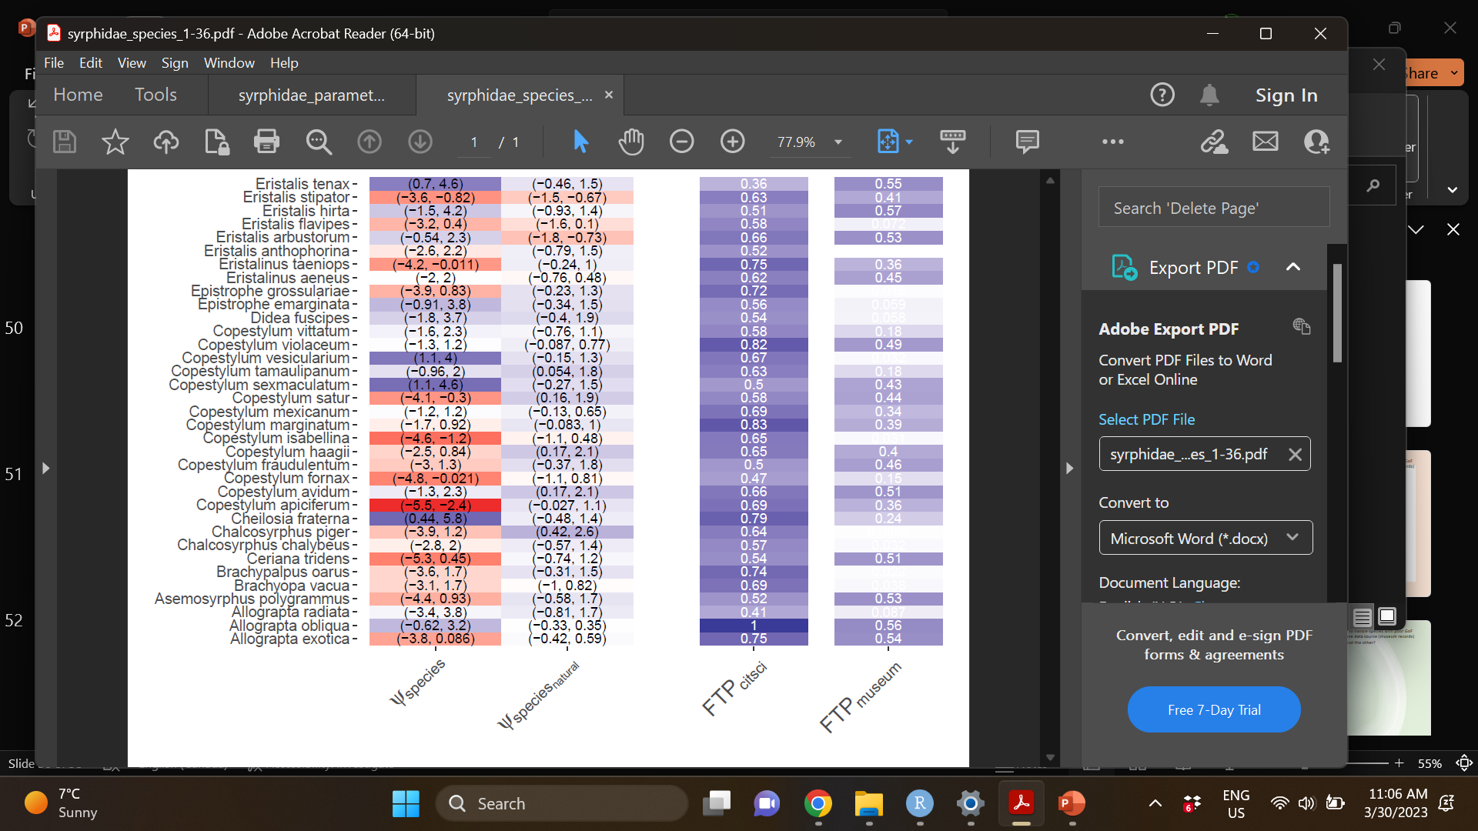

**Supplemental Table 3:** Species-specific occupancy intercept effects (column 1), species-specific effects of natural habitat area (column 2), and goodness of fit metric Freeman-Tukey P-value discrepancy for community science data (column 3) and research collections data (column 4) for a subset of hoverfly species.

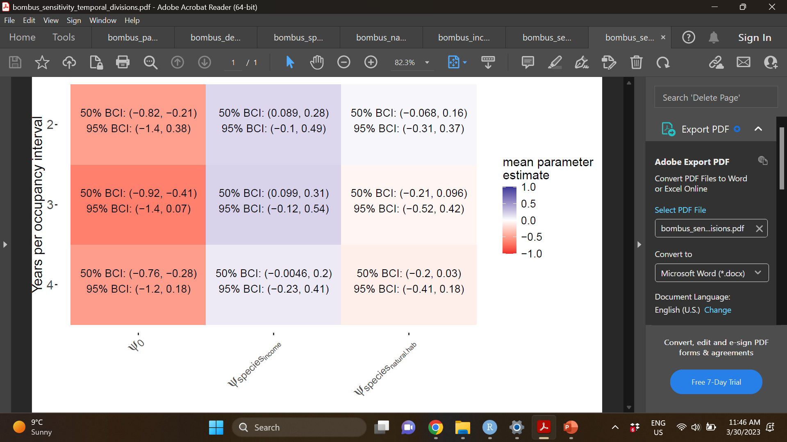

**Supplemental Table 4:** Temporal division sensitivity analysis (bumble bees)

**Supplemental Table 5:** Temporal division sensitivity analysis (hoverflies)

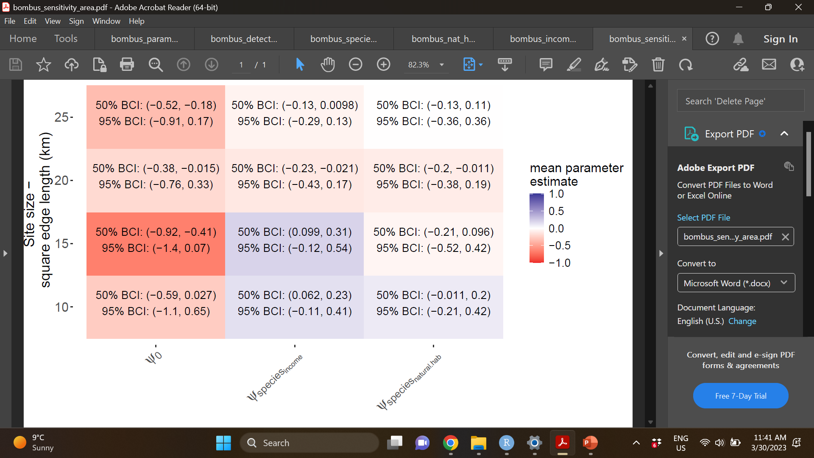

**Supplemental Table 6:** Spatial grain sensitivity analysis (bumble bees)



**Supplemental Table 7:** Spatial grain sensitivity analysis (hoverflies)

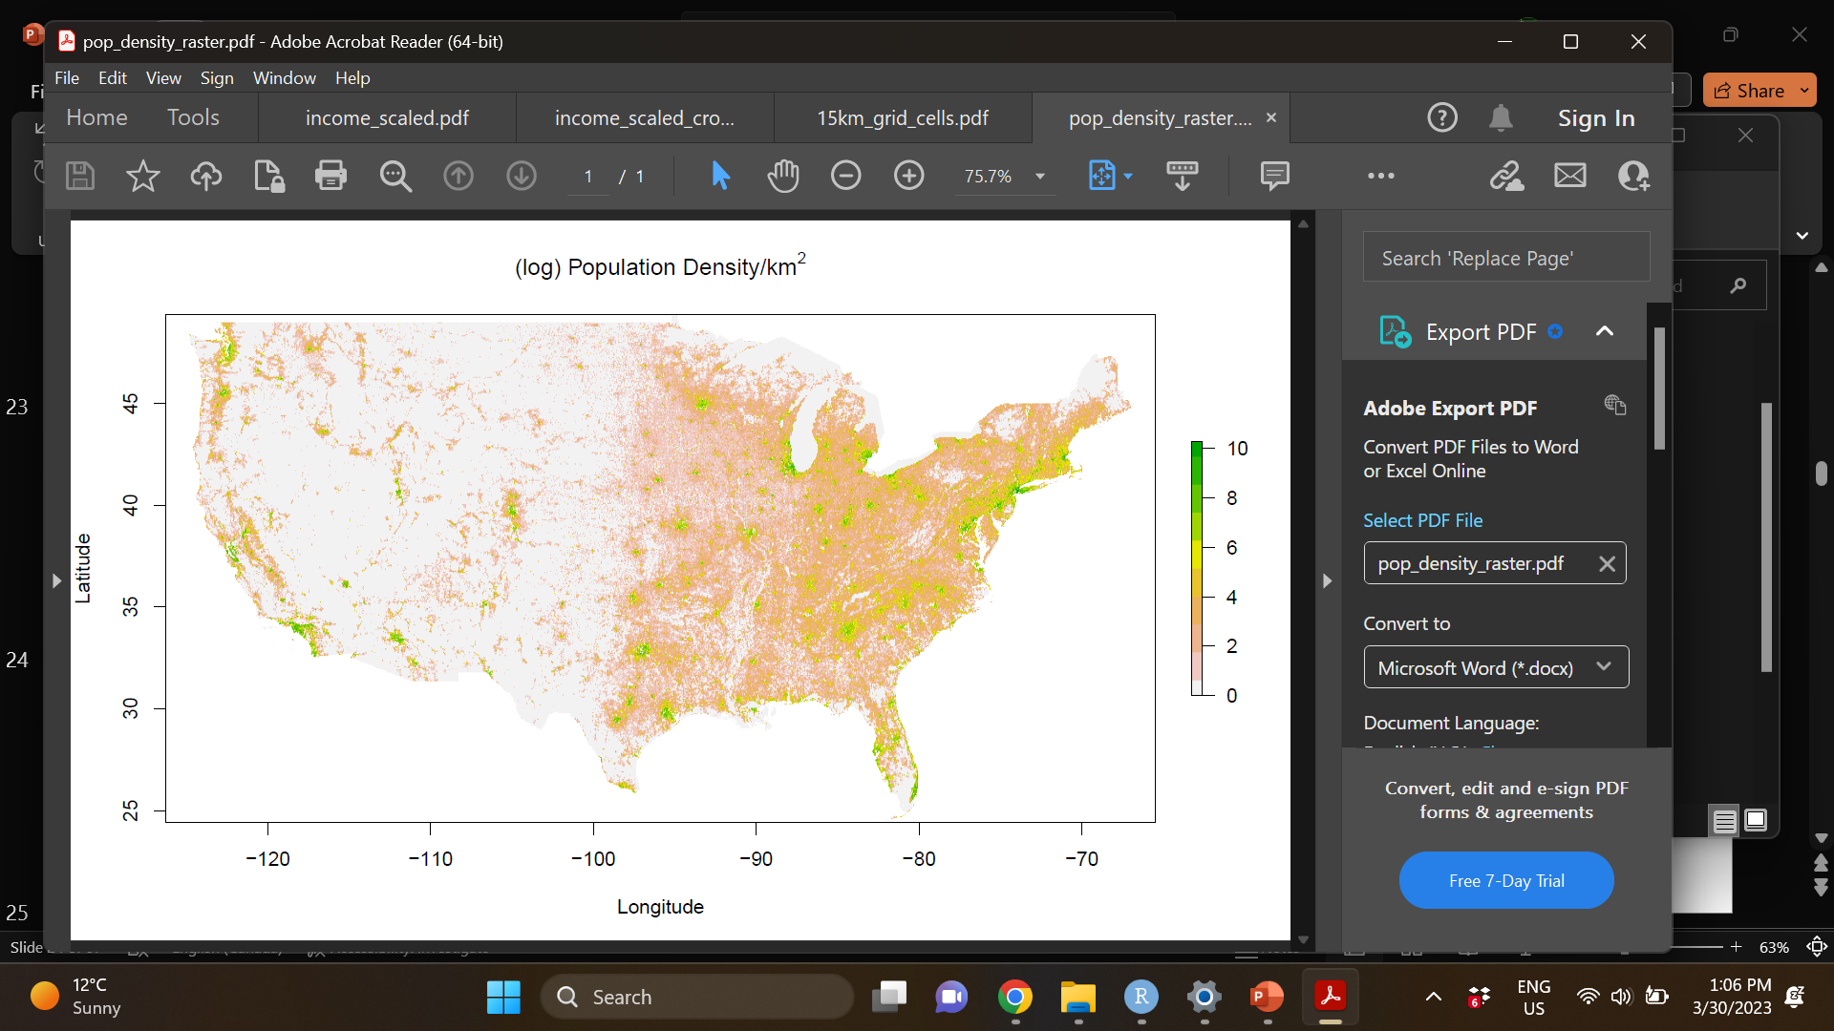

**Supplemental Figure 1:** Population density across the continental U.S.

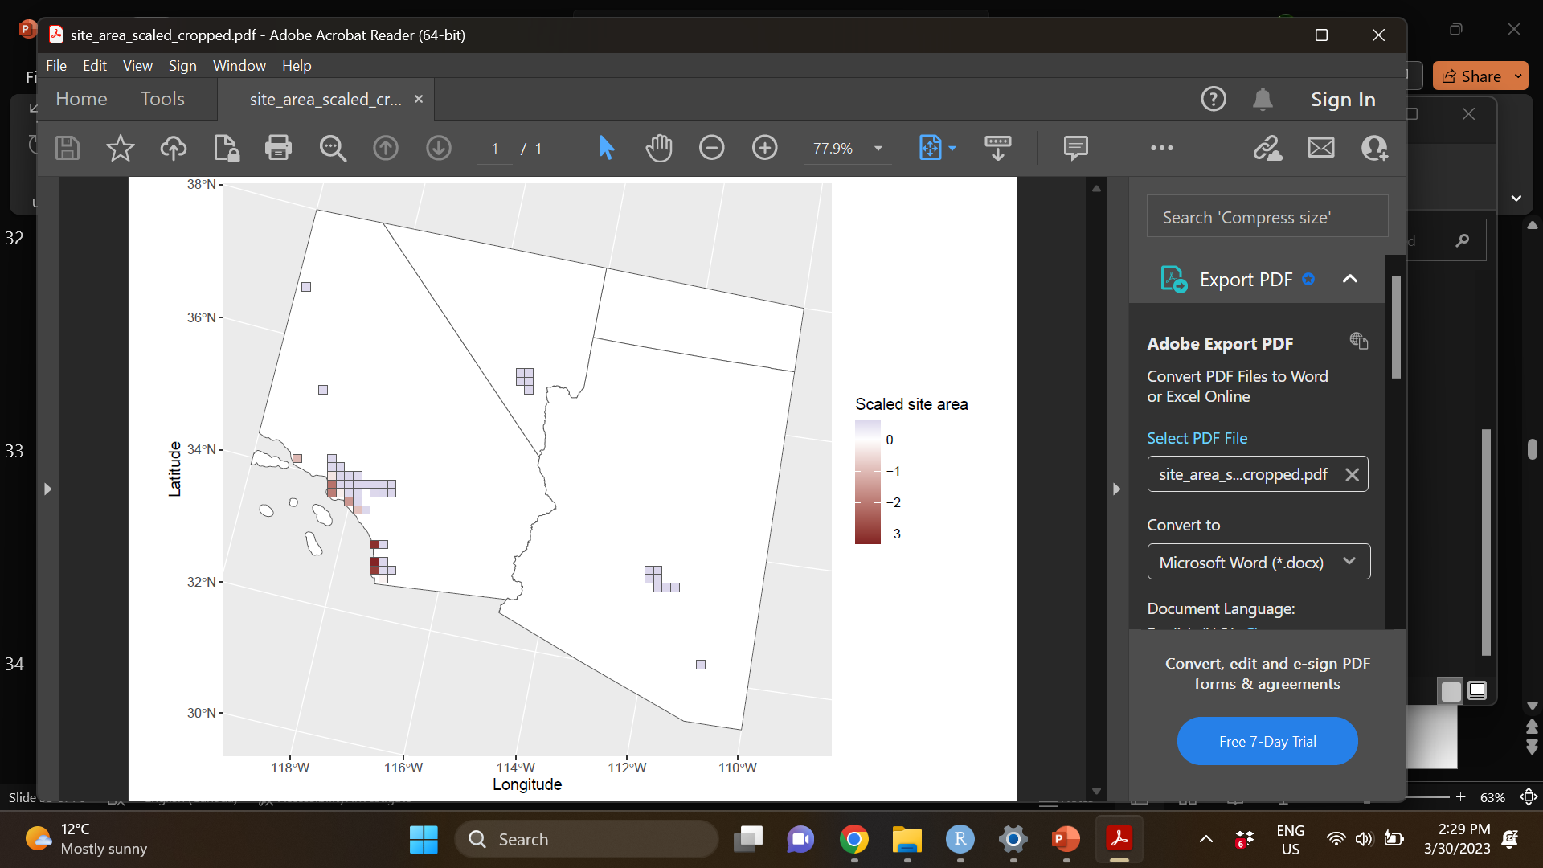

**Supplemental Figure 2:** Site area across all urban landscape sites (A) and for an inset of sites in the southwestern U.S. (B). Site area is the sum of the number of pixels containing any type of land cover (not open water) and that also falls within the continental U.S. international borders.



**Supplemental Figure 3.** Natural habitat area (green pixels) in select urban landscapes (Los Angeles, California, metropolitan area site cluster).





**Supplemental Figure 4.** Relative median household income in Sacramento County, California, (A) and in Cook County Illinois (B). Note that income is relative to the state mean, where a block group value greater than 1 indicates a block group that is more affluent than the average block group in the same state. Grey block groups indicate block groups with no data, which occurs when a no people or a finitely small number of people permanently reside in the block group, i.e., block groups dominated by undeveloped/protected land, block groups dominated by agriculture, or block groups dominated by some other permanent fixture prohibiting permanent residence such as an airport or a military or engineering installation (U.S. Census Bureau, 2022).





**Supplemental Figure 5:** Scaled income across all urban landscape sites (A) and for an inset of sites in the southwestern U.S. (B). Income was calculated as the mean standardized median household income across all census block groups within each urban landscape.





**Supplemental Figure 6:** Natural habitat across all urban landscape sites (A) and for an inset of sites in the southwestern U.S. (B). Natural habitat area is the sum of the number of pixels containing natural habitat land cover classes proportional to the land cover area (within the continental U.S. international borders) for each urban landscape.

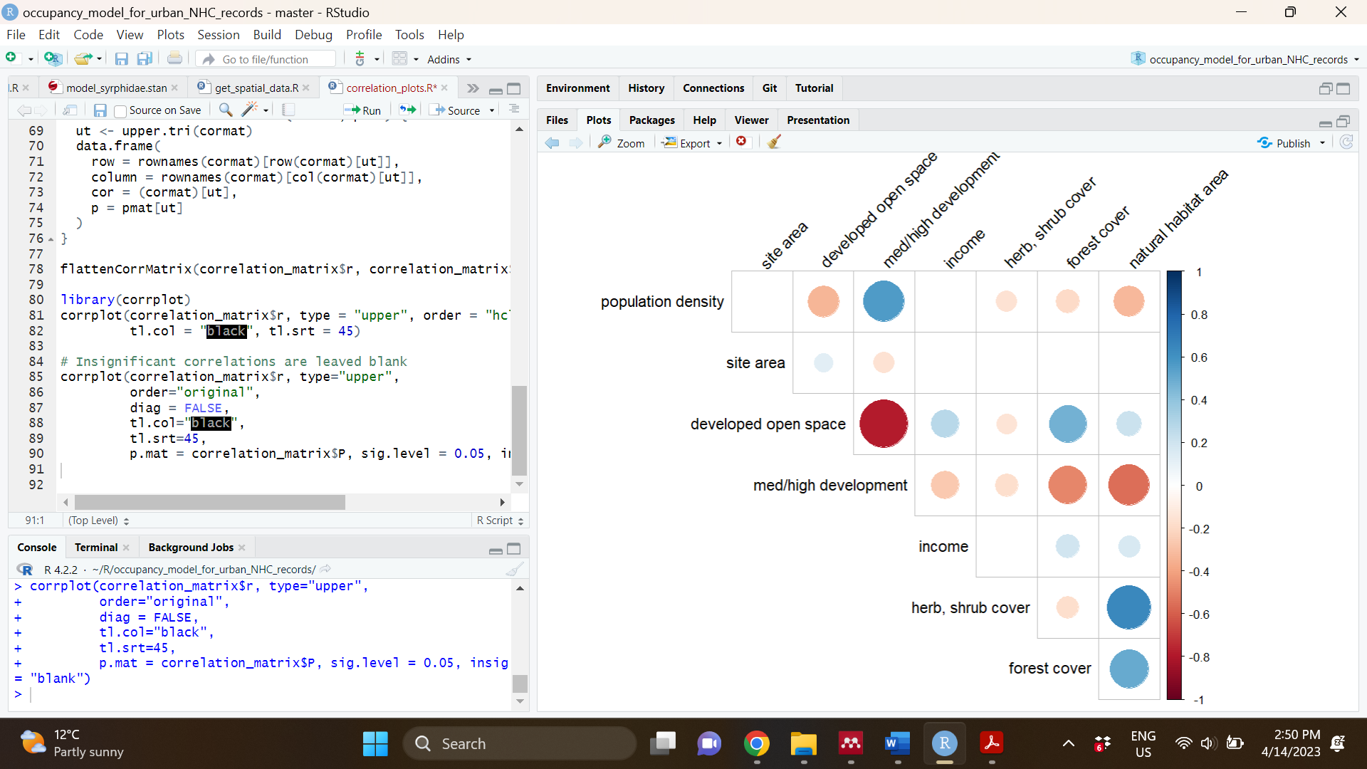

**Supplemental Figure 7:** Pearson correlation coefficients for urban landscape socioeconomic and land cover variables. Magnitude and direction of correlations are illustrated by circle size and colour. Statistically insignificant correlations are left blank (threshold p-value = 0.05). Note that natural habitat area is the sum of herbaceous and shrub land cover classes with forest cover (as well as wetlands, not included here).

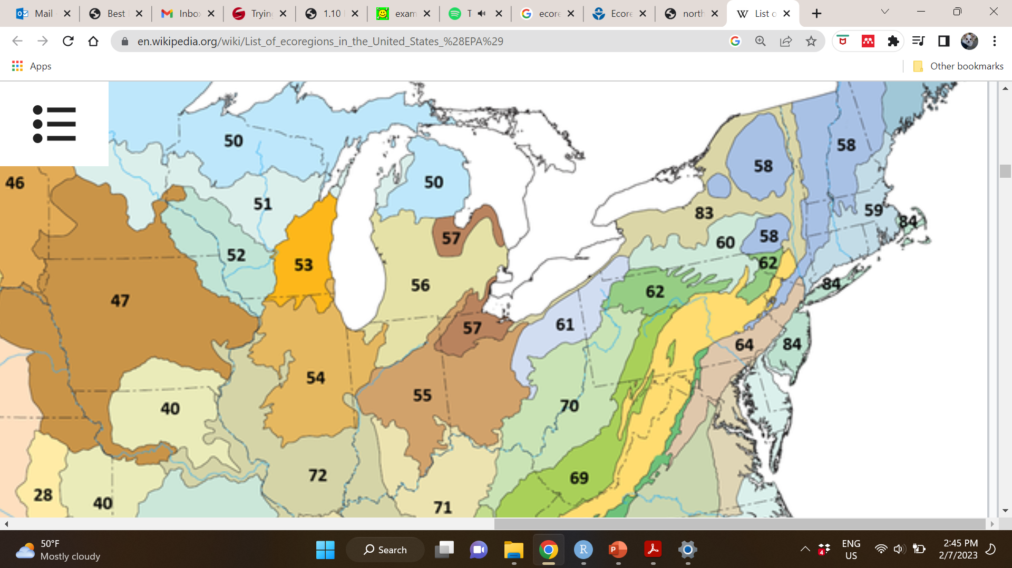

**Supplemental Figure 8:** U.S. level 3 ecoregions used as spatial clustering units to account for spatial correlation among sites (intermediate spatial clustering level).

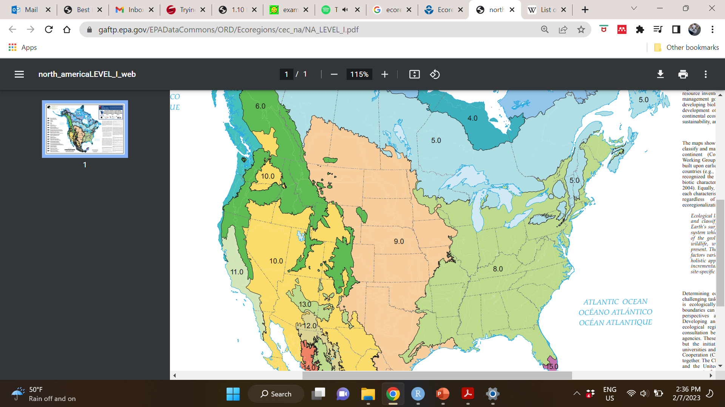

**Supplemental Figure 9:** U.S. level 1 ecoregions used as spatial clustering units to account for spatial correlation among sites (broadest spatial clustering level).

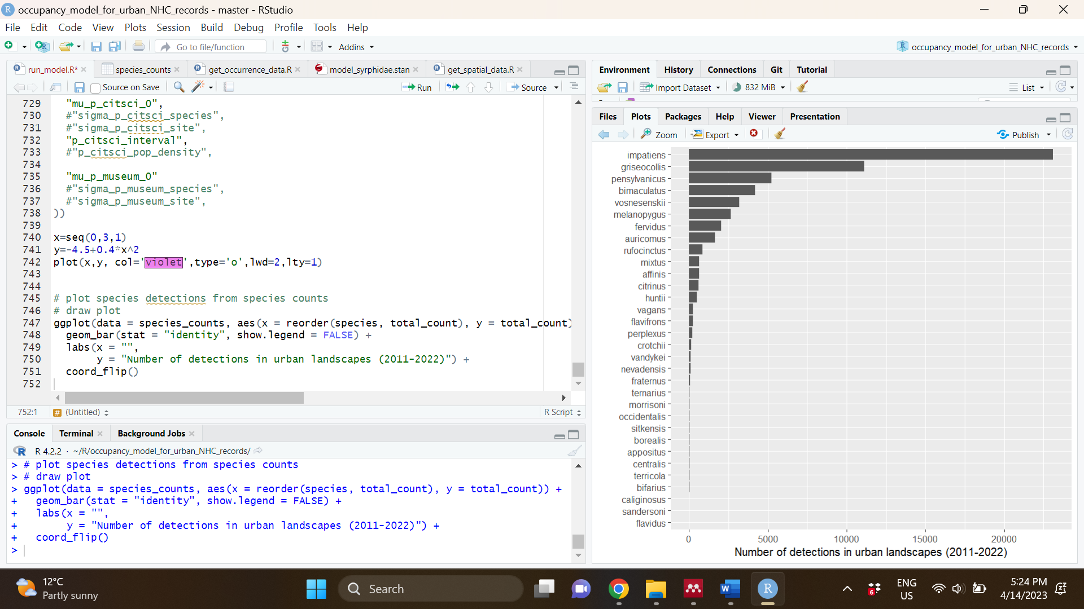

**Supplemental Figure 10**: Number of detections per species (bumble bees) in urban landscape sites during the temporal extent of the study. Species epithets are listed along the y-axis in order of descending number of total detections.

**Supplemental Figure 11**: Number of detections per species (hoverflies, top 35 most detected species out of 126 total species) in urban landscape sites during the temporal extent of the study. Species names are listed along the y-axis in order of descending number of total detections.

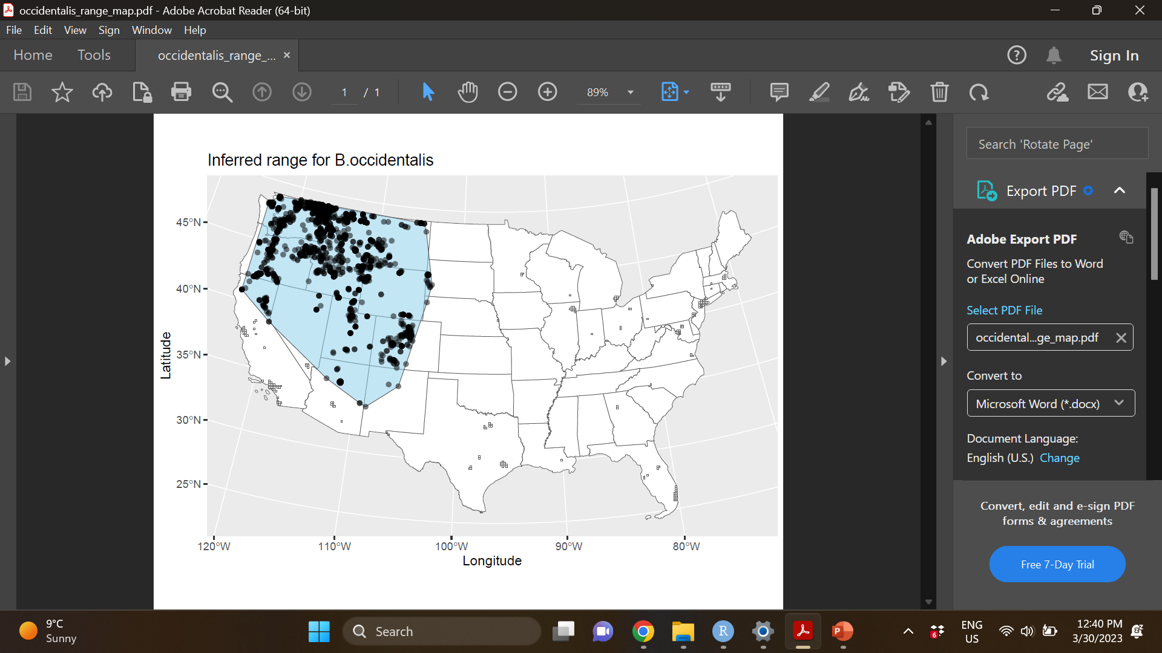

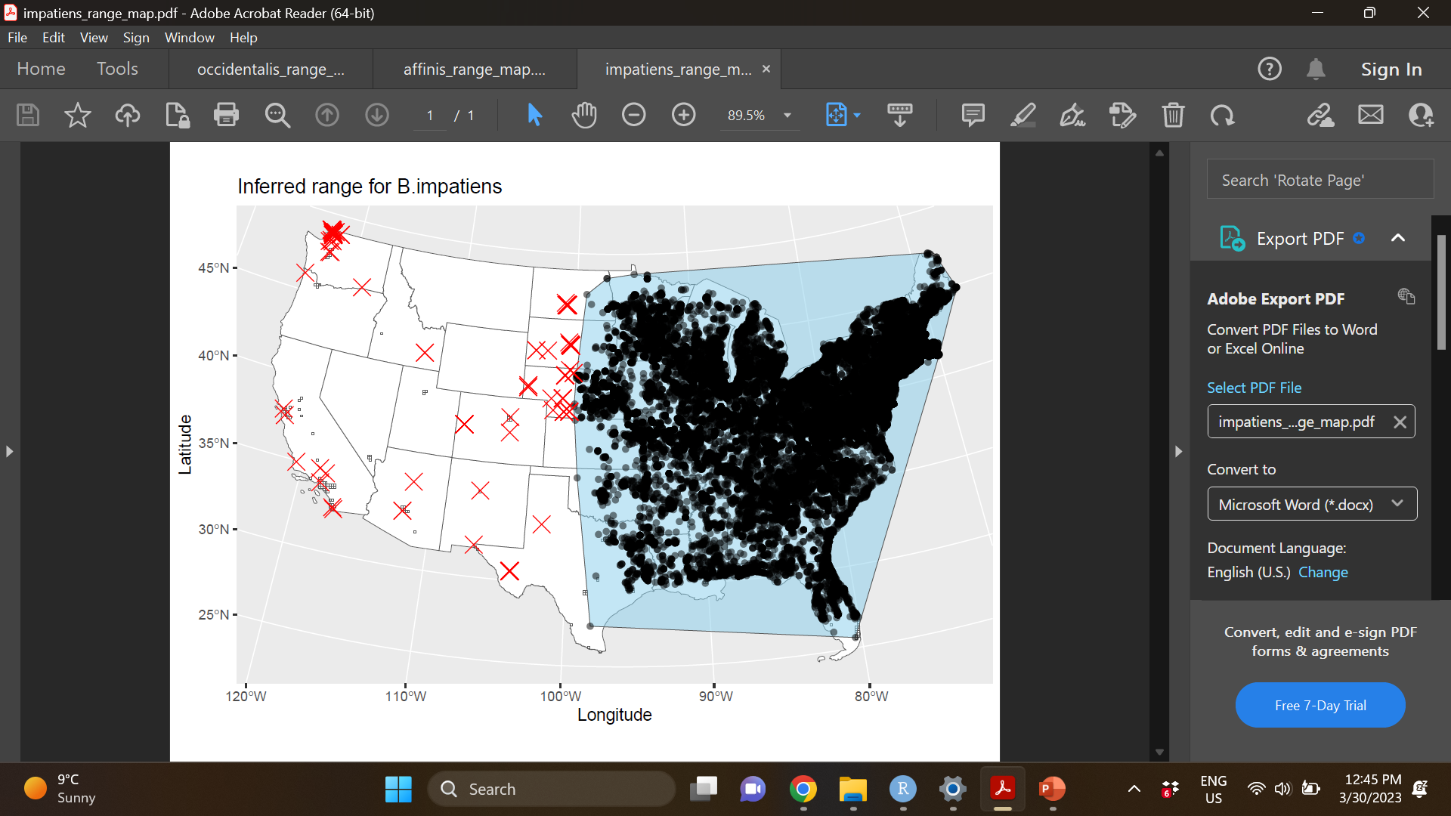

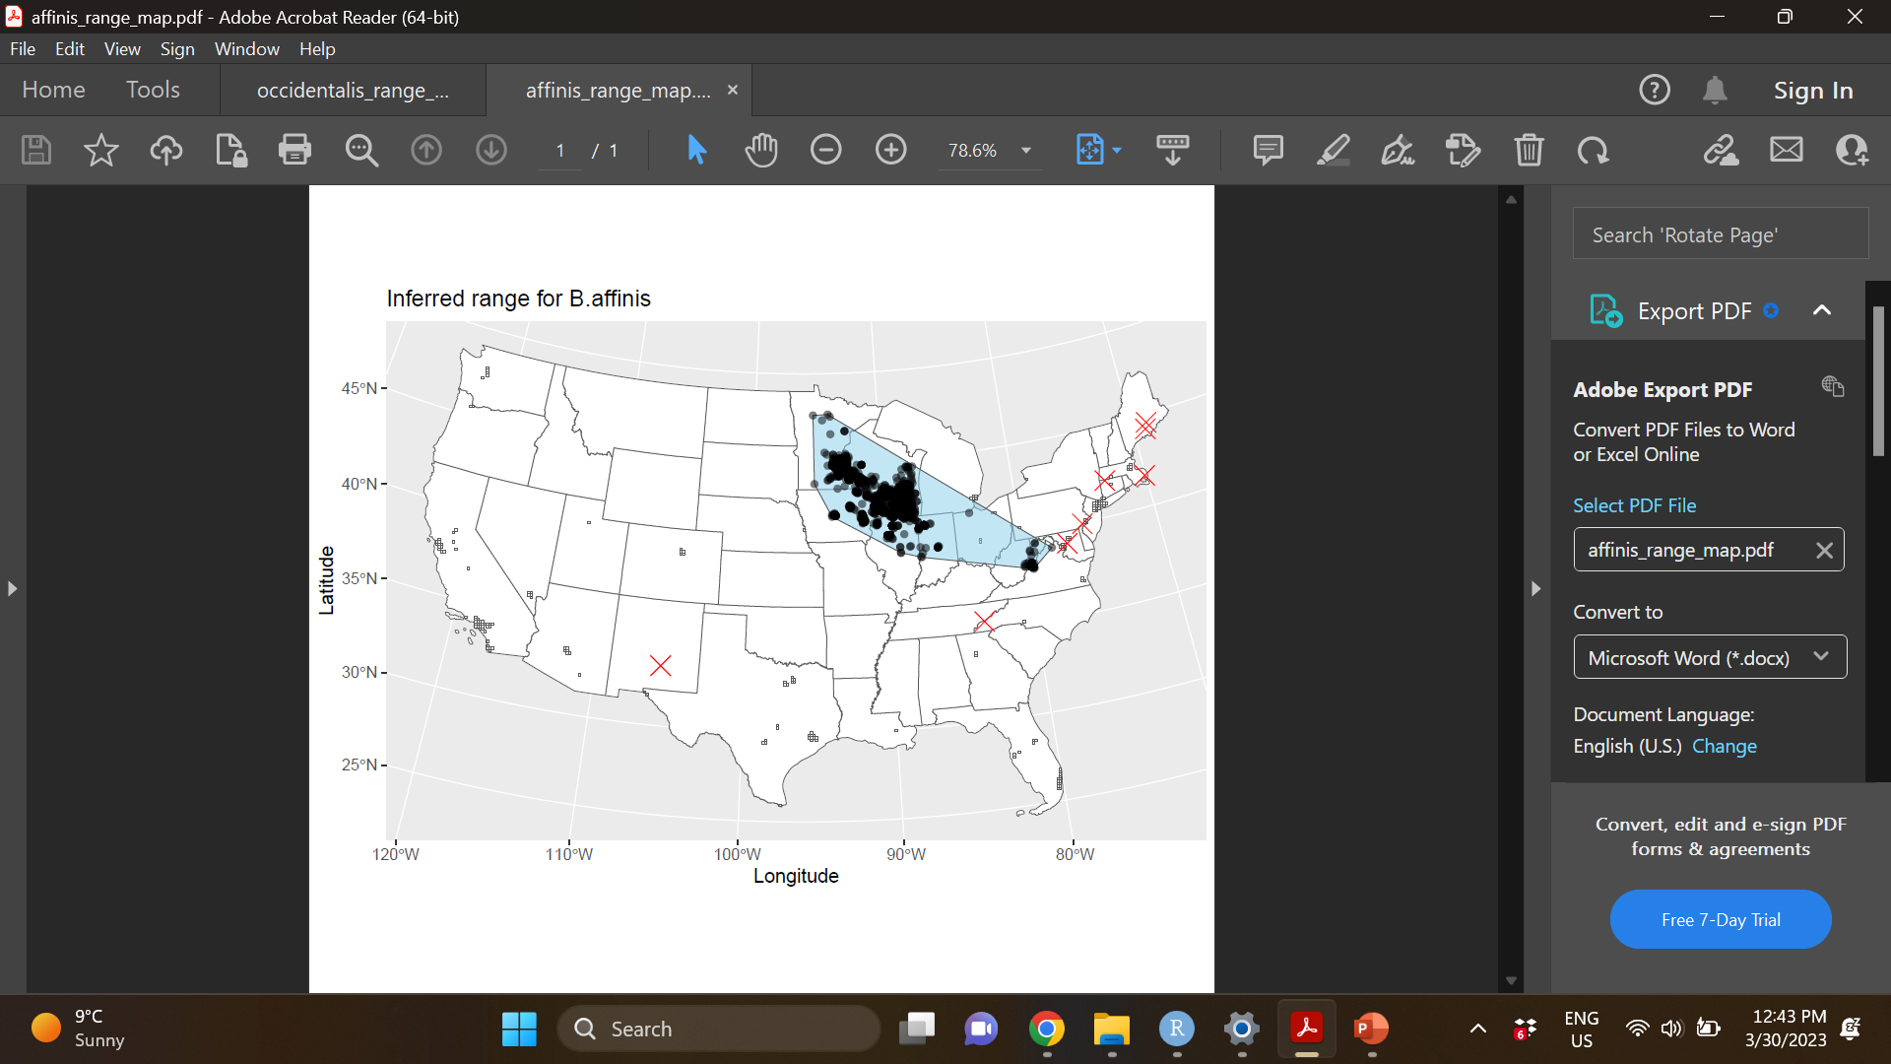

**Supplemental Figure 12:** Demonstrative species range maps. Range maps were drawn for each species by tracing a convex hull (light blue) around all detections recorded between 2000 – 2022 (black circles) (A). For two species we selectively filtered out occurrence points in well-known rapidly expanding (B) or declining (C) range areas (red exes).

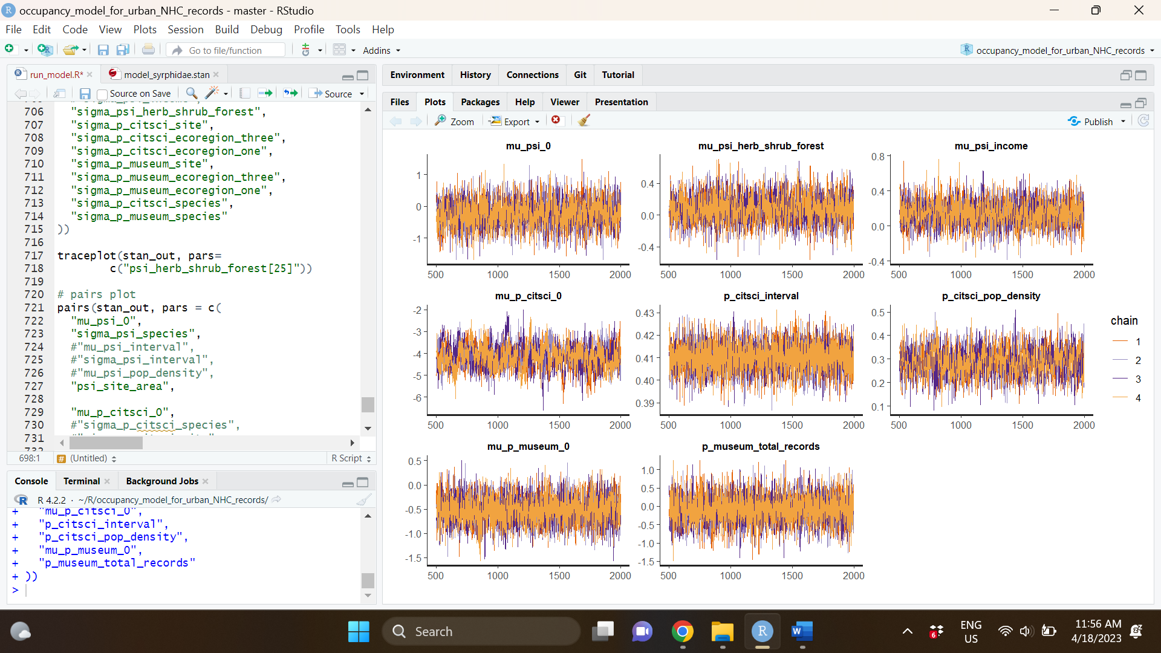

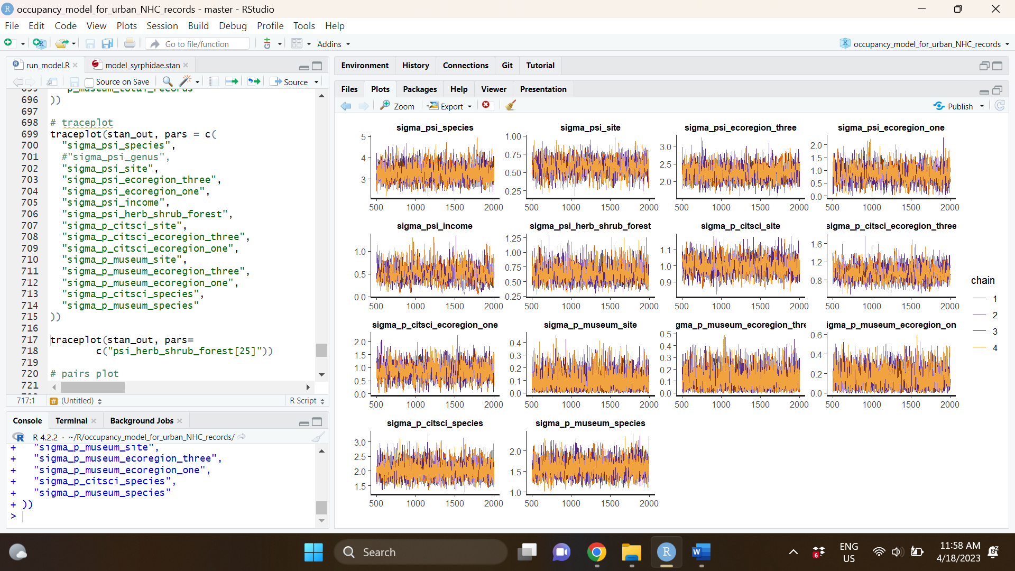

**Supplemental Figure 13:** Traceplot for bumble bees for occupancy (top) and detection (bottom) parameters.

**Supplemental Figure 14:** Traceplot for hoverflies

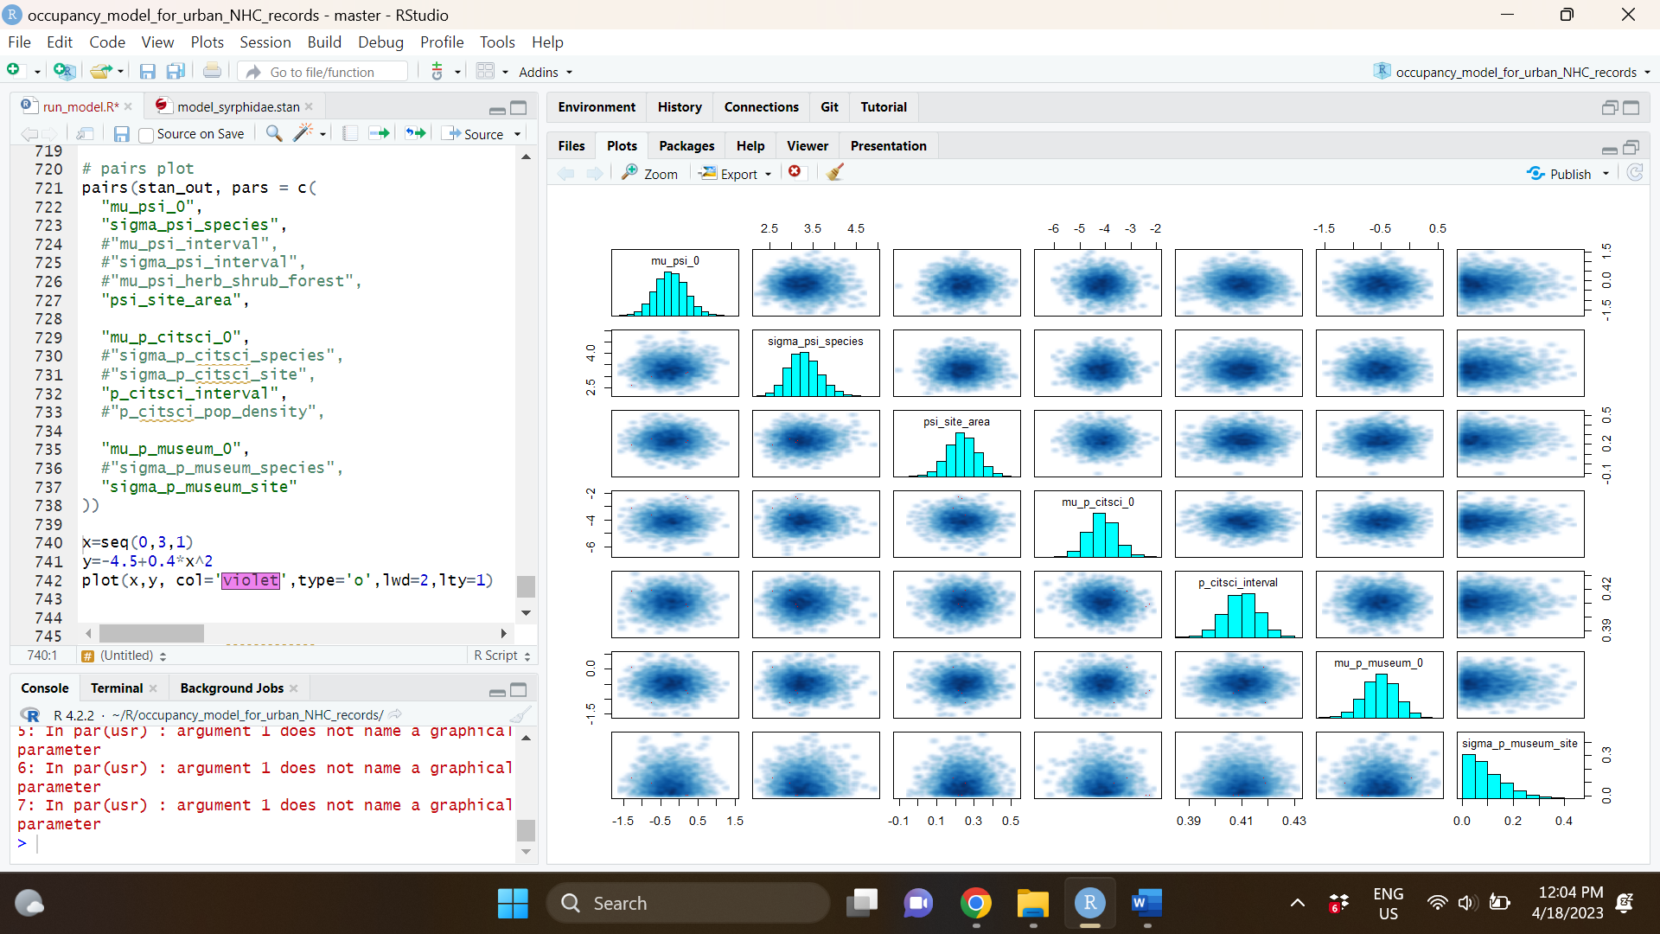

**Supplemental Figure 15:** Pairs plot for select parameters (bumble bees). Note that variance terms are constrained to be positive and this can cause the posterior to be sharply bounded at 0 (such as for sigma_p_museum_site).

**Supplemental Figure 16:** Pairs plot for select parameters (hoverflies). Note that variance terms are constrained to be positive and this can cause the posterior to be sharply bounded at 0 (such as for sigma_p_museum_site).

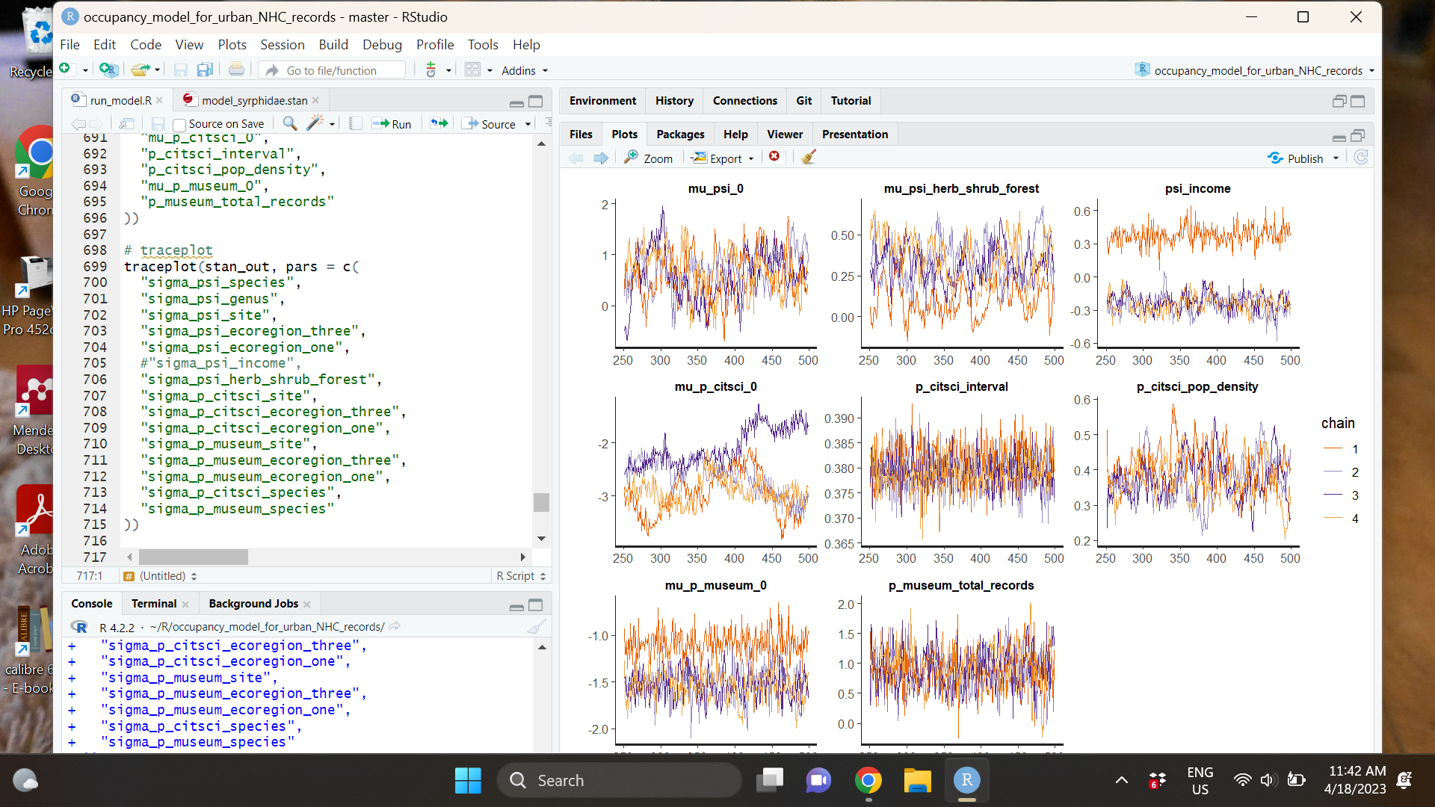

**Supplemental Figure 17:** Traceplot showing non-converging posterior distributions for hoverflies when including an income as a predictor of occupancy.

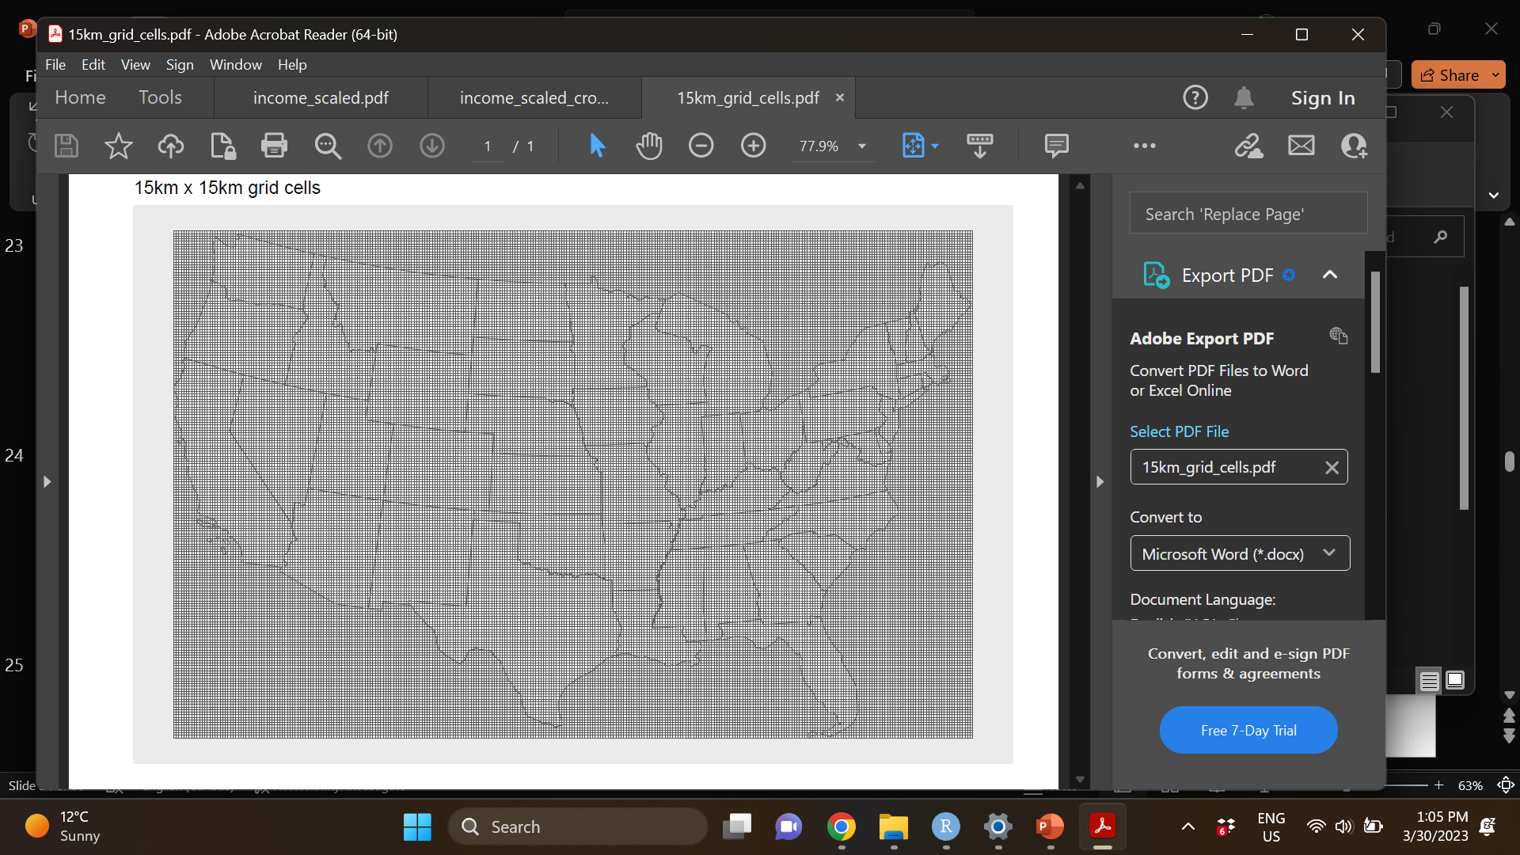

**Supplemental Figure 18:** 30 kmby 30 km grid overlayed on the continental United States. For the second model quantifying rarity, we randomly subsampled sites from this grid (dropping sites that did not contain at least 25% land area).

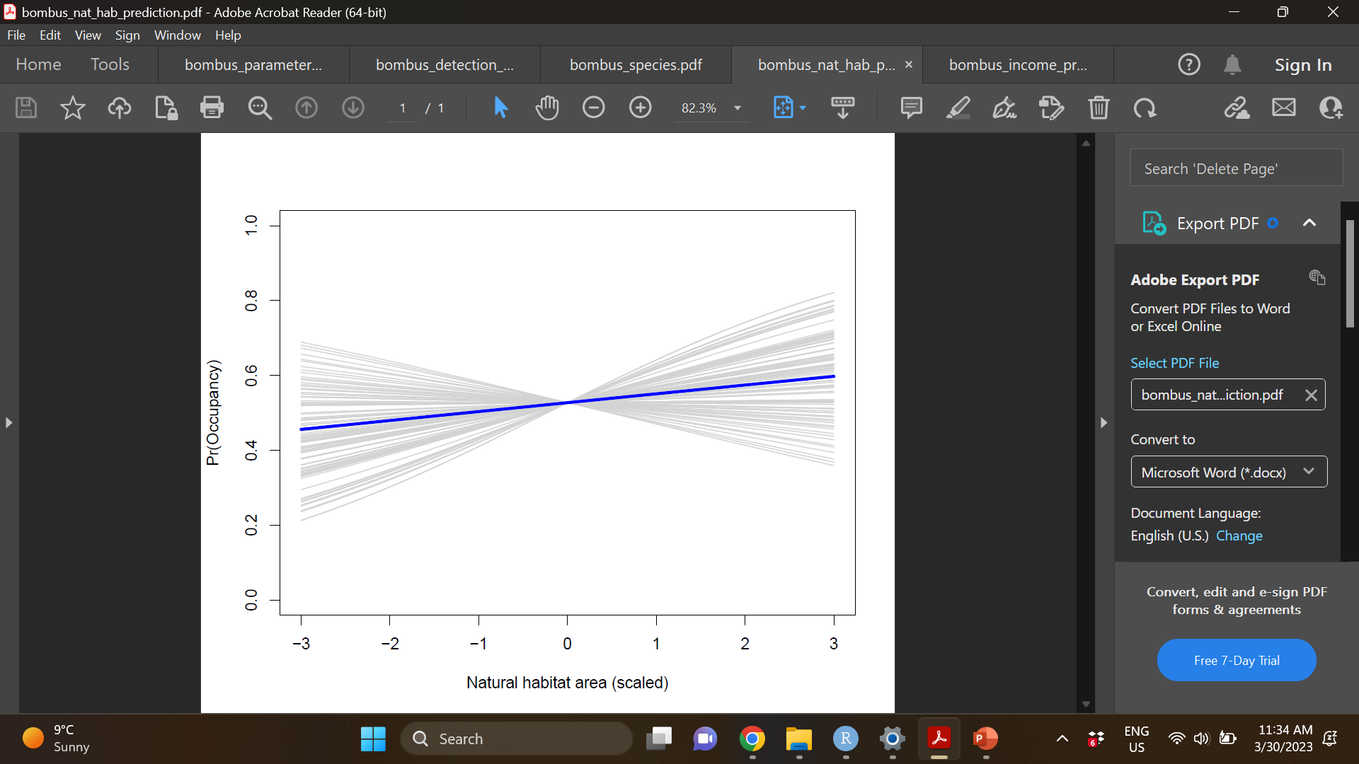

**Supplemental Figure 19:** Association between natural habitat area (units = standard deviations from the mean site natural habitat area) and (bumble bee) site occupancy probability. Blue line indicates the mean of the posterior distribution, while grey lines are 100 random draws from the posterior distribution displaying uncertainty around the mean value (all other parameters were held at their mean values).

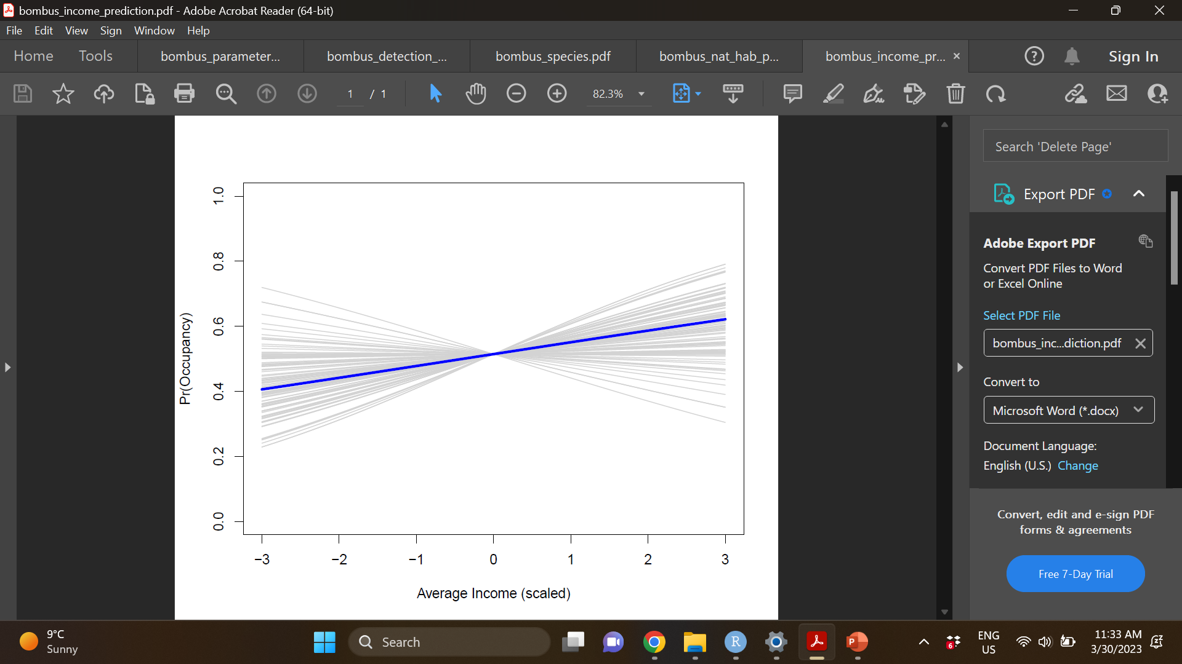

**Supplemental Figure 20:** Association between income (units = standard deviations from the mean site income) and (bumble bee) site occupancy probability. Blue line indicates the mean of the posterior distribution, while grey lines are 100 random draws from the posterior distribution displaying uncertainty around the mean value (all other parameters were held at their mean values).

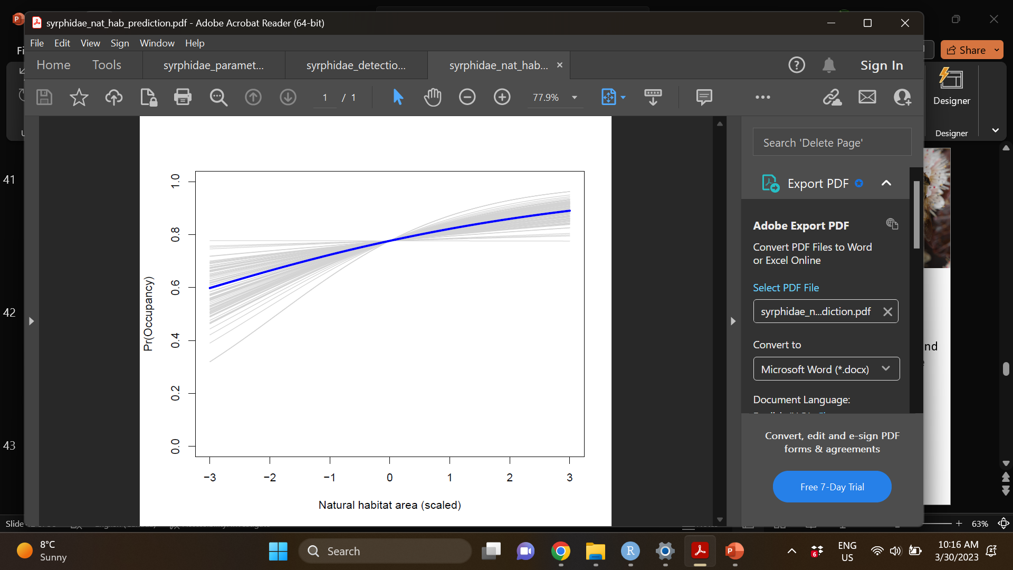

**Supplemental Figure 21:** Association between natural habitat area (units = standard deviations from the mean site natural habitat area) and (hoverfly) site occupancy probability. Blue line indicates the mean of the posterior distribution, while grey lines are 100 random draws from the posterior distribution displaying uncertainty around the mean value (all other parameters were held at their mean values).

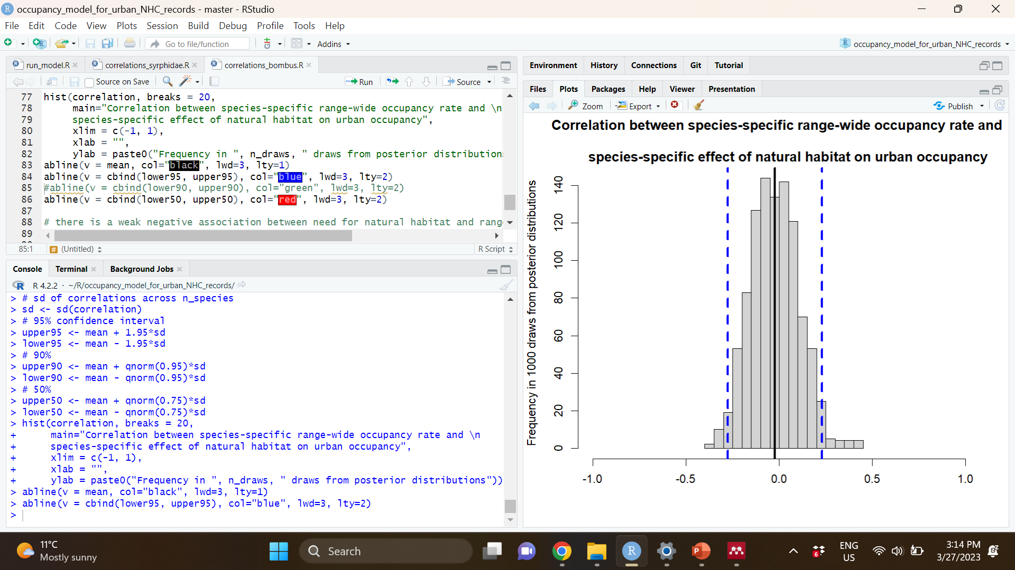

**Supplemental Figure 22:** correlation between species-specific range wide occupancy rate and species-specific effect of natural habitat area on urban occupancy (bumble bees). Black line indicates mean correlation across 1,00 draws from each posterior distribution, blue lines indicate 95% confidence interval.

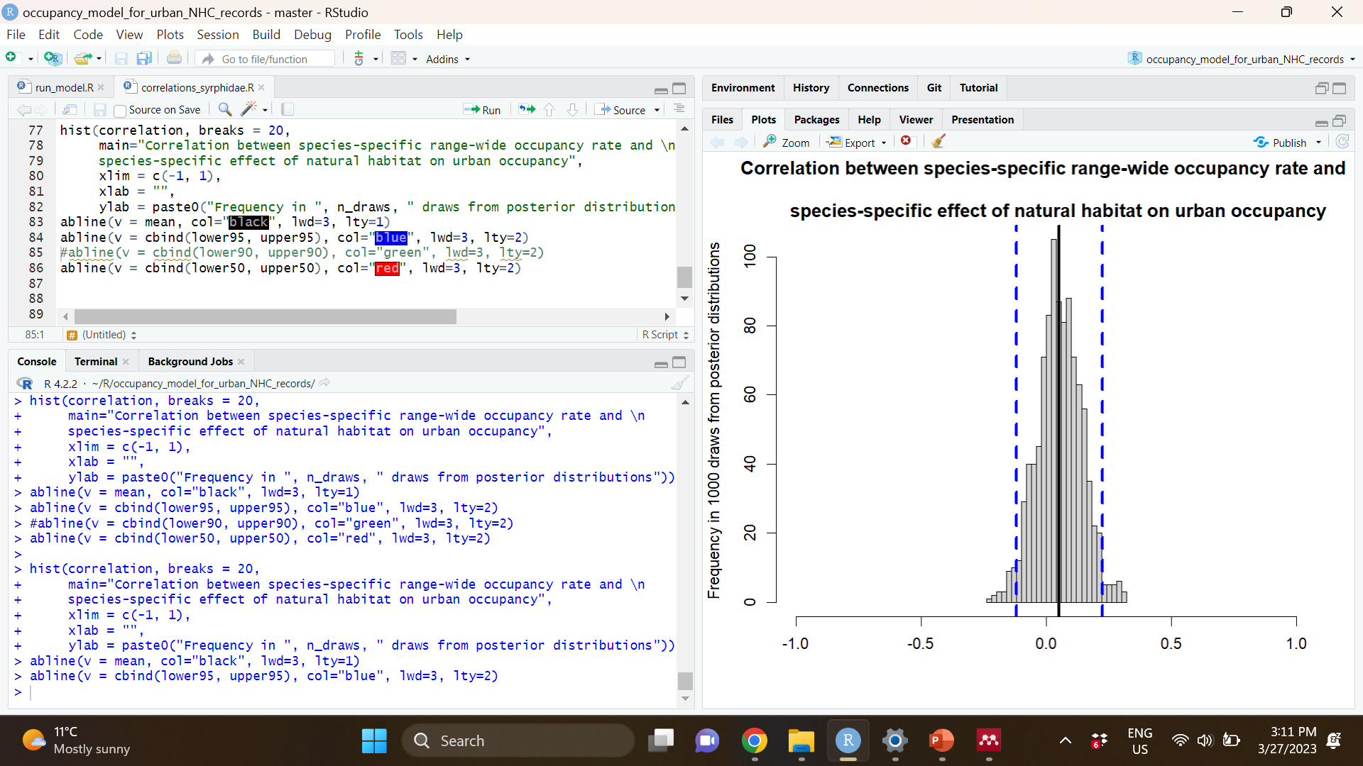

**Supplemental Figure 23:** correlation between species specific range wide occupancy rate and species-specific effect of natural habitat area on urban occupancy (hoverflies). Black line indicates mean correlation across 1,00 draws from each posterior distribution, blue lines indicate 95% confidence interval.

**Supplemental Figure 22:** Simulation parameter inputs and model estimates

**Supplemental Figure 23:** Simulation parameter inputs and model estimates (with very sparse research collections data)

**Supplemental Figure 24:** FTP values showing lack of fit despite accurate recover of ecological parameters of interest (with very sparse research collections data)

~~We used a composite score of natural habitat area that encompasses any form of undeveloped vegetation cover, including herb/grassland, shrub/scrubland, forest (including coniferous, deciduous or mixed forest) or wetland. A lack of bumble bee response to natural habitat area could arise if there are compositional mismatches between the natural habitat subcategory to which a species is best adapted versus the subcategory of natural habitat that is available in a particular urban landscape. We note that natural habitat composition varies by region rather than being homogenous across the county, e.g., where coastal California urban natural habitat composition includes more shrub/scrubland cover () versus forest cover in the northeastern U.S. (). Thus, the urban natural habitat composition in the urban landscapes considered here generally corresponds to the natural cover composition that each species may have experienced prior to urbanization. Nonetheless, even within regions, different species may benefit more from different types of specific landscape cover (Harrison et al., 2018; Novotny et al., 2021). To pinpoint targeted urban management plans, species-specific case studies could target highest-priority species, restrict analysis to the core of the species’ range and use model selection approaches to identify the most important habitat variables. For example, Janousek et al., 2023, find that forest edges are associated with increased~~ *~~B. occidentalis~~* ~~occupancy; using this information, habitat managers could maintain urban parks that maximize the presence of these types of transitionary natural habitat areas in urban natural parks. Variation in the overall quality of urban natural habitat may also confound our results. Urban natural parks may vary in many ways that may impact pollinators including plant species richness, perennial plant age/size, structure and complexity of woody vegetation, proportion of native species, abundance of dead/decaying plant materials, water bodies, sunlight and overall floral availability (Nielsen et al., 2014). Pollinators may also benefit from moderate disturbances in parks that maintain more ruderal areas (Ockinger et al., 2009). Future studies could combine multi-city pollinator data such as ours with coordinated surveys of natural area vegetation quality to determine whether among-city differences in natural habitat management practices (as opposed to differences in total area of natural habitat) urban landscape occupancy.~~